**AP BIOLOGY EXAM REVIEW GUIDE**

“The price of success is hard work, dedication to the job at hand, and the determination that whether we win or lose, we have applied the best of ourselves to the task at hand.”

**CONCEPT 1 - BIOCHEMISTRY**

1. CHNOPS- most common elements in all living matter
2. Bonds- ionic (transfer electrons), covalent (sharing- polar/unequal sharing and non-polar/equal sharing), hydrogen (weak bonds between hydrogen and negatively charged items), hydrophobic interactions (how non-polar compounds congregate together- lipids)
3. pH
4. acid-base/ 0-14, # of H ions determines scale; logarithmic- pH 3 = 10-3 = 1/1000
5. blood- 7.4, stomach- 2, small intestine- 8; enzymes are specific to pH
6. Water properties- polarity, cohesion(attraction to other water molecules), adhesion (attraction to other charged compounds) low density when frozen, versatile solvent, high heat of fusion/vaporization; surface tension
7. Organic molecules - monomers are simplest form of all; monomers join together via dehydration synthesis (loss of water) to make polymers; polymers are broken down via hydrolysis (input of water)
8. Carbohydrates- CHO 1:2:1 ratio, monomer= monosaccharides, 2=disaccharides, 3 or more= polysaccharides

* Used for energy (cell respiration)
* Examples

1. glucose- immediate energy to make ATP
2. starch- stored energy in plants
3. glycogen- stored energy in animals (stored in liver)
4. cellulose- plant cell wall
5. Lipids – C, H, O (not a 1:2:1 ratio) *P only in phospholipids
6. fats, waxes, oils and sterols
7. Saturated fats have single bonds between carbons, unsaturated fats have at least one double bond between carbons (kinky); plants make polyunsaturated; animals make monounsaturated
8. Phospholipids make up cell membranes (double layer) and are amphipathic- hydrophilic and hydrophobic
9. Uses- in all membranes; stored energy, protection, insulation, myelin sheath of nerves
10. Proteins- C, H, O, N (may have other elements in R group)
11. Monomer- amino acids (20 total types), 2=dipeptide, 3 or more= polypeptide
12. Parts of amino acid= carboxyl group (COOH) on one end, amino group on the other end (NH2), central carbon and variable R group (can be hydrophobic or hydrophilic) which determines chemical properties.
13. Protein Folding- shape determines function; primary= a.a. chain; secondary= beta pleated sheet or alpha helix( hydrogen bonds); tertiary=globular; folds in on itself (disulfide bridges, hydrogen bonds, hydrophobic interactions; ionic bonding); quartenary= more than one polypeptide.
14. Uses- protein carriers in cell membrane, antibodies, hemoglobin, enzymes, most hormones
15. Nucleic acids – C, H, O, N
16. Monomer= nucleotide, 2 = dinucleotide, 2 or more polynucleotide
17. Nucleotide made up of sugar, phosphate and base
18. Used to store genetic information
19. DNA is double stranded, has deoxyribose, A, G, C, T
20. RNA is single stranded, has ribose, A, G, C, U
21. mRNA- copies genetic message; rRNA- attaches mRNA and makes up ribosomes (most common);tRNA- carries amino acids; DNA- carries genetic code
22. Enzymes
23. Biological catalysts (made of protein) that speed up rate of chemical reactions by lowering activation energy required for reaction to occur
24. Enzyme has active site (exposed R groups) where reaction occurs
25. Enzymes can break down substance (catabolic reaction) or build up substances (anabolic)
26. Enzyme/substrate complex is formed
27. Substrate is what enzyme acts on
28. Rate is determined by collisions between substrate and enzyme
29. Ends in –ase, named after substrate often
30. Enzyme is specific to substrate; the substrate must be complementary to the surface properties (shape and charge) of the active site (which is made up of R groups with specific chemistry, i.e. hydrophobic).
31. Enzyme rate is affected by:

* **pH** (optimal for each enzyme),
* **temperature** (optimal for each enzyme but in general increased temp means increased collisions so rate goes up initially; too much heat can denature enzyme), enzyme concentration (more enzyme faster rate or vice versa)
* **substrate concentration** (more substrate faster rate; vmax is fastest enzyme can work when saturated)

1. Inhibition-competitive inhibition (something competes for active site; can be overcome with more substrate)
2. Non-competitive inhibition- attaches at allosteric site and changes shape of enzyme so it is not functional; can not be overcome with more substrate
3. Coenzymes (organic; NAD and vitamin B etc.) and cofactors (inorganic; zinc, magnesium etc.) interact with enzymes to put them into the right structure to do work.

***Vocabulary***

active site

allosteric site

amino acid

amphipathic

anabolic

carbohydrate

carbon

catabolic

catalyst

coenzyme

denaturation

disaccharide

hydrogen bond

hydrophilic

hydrophobic

ion

lipid

macromolecule

monomer

monosaccharide

non-polar molecule

nucleic acid

nucleotide

organic molecule

peptide bond

polar molecule

polymer

protein

substrate

water

***Thinking Practice***

1. If the following molecules were to undergo a dehydration synthesis reaction, what molecules would result? **Circle** the parts of each amino acid that will interact and **draw** the resulting molecule.

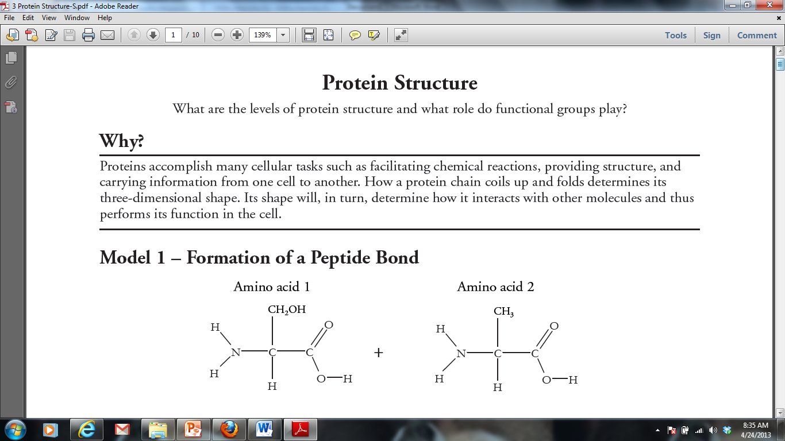

1. Construct a bar graph that displays the relative amounts of hydrogen, carbon, oxygen, and nitrogen in each of the four types of macromolecules (carbohydrates, lipids, proteins, nucleic acids).
2. Describe the relationship between substrate concentration and reaction rate shown in the graph below and propose an explanation for it.

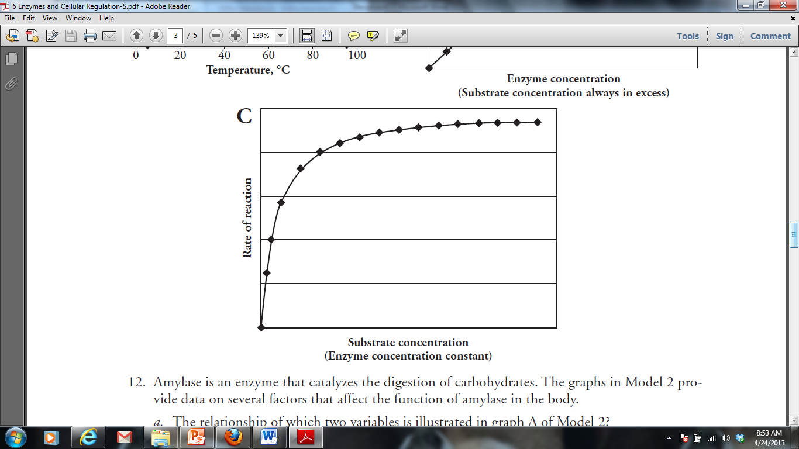

1. DNA polymerase from *T. aquaticus (Taq)* is used in PCR (polymerase chain reaction). PCR is a technique where millions of copies of DNA can be made from one original copy. In this method, the target DNA molecule is subjected to temperatures over 95 °C to make the double-stranded DNA separate. The temperature is then lowered slightly to allow primers to anneal before the *Taq* polymerase catalyzes the reactions to incorporate new nucleotides into the complementary strands. The cycle is then repeated over and over until there are millions of copies of the target DNA.
2. Predict why this bacterial polymerase is used instead of a human polymerase.
3. What would happen if you used a human polymerase in a series of PCR reactions?

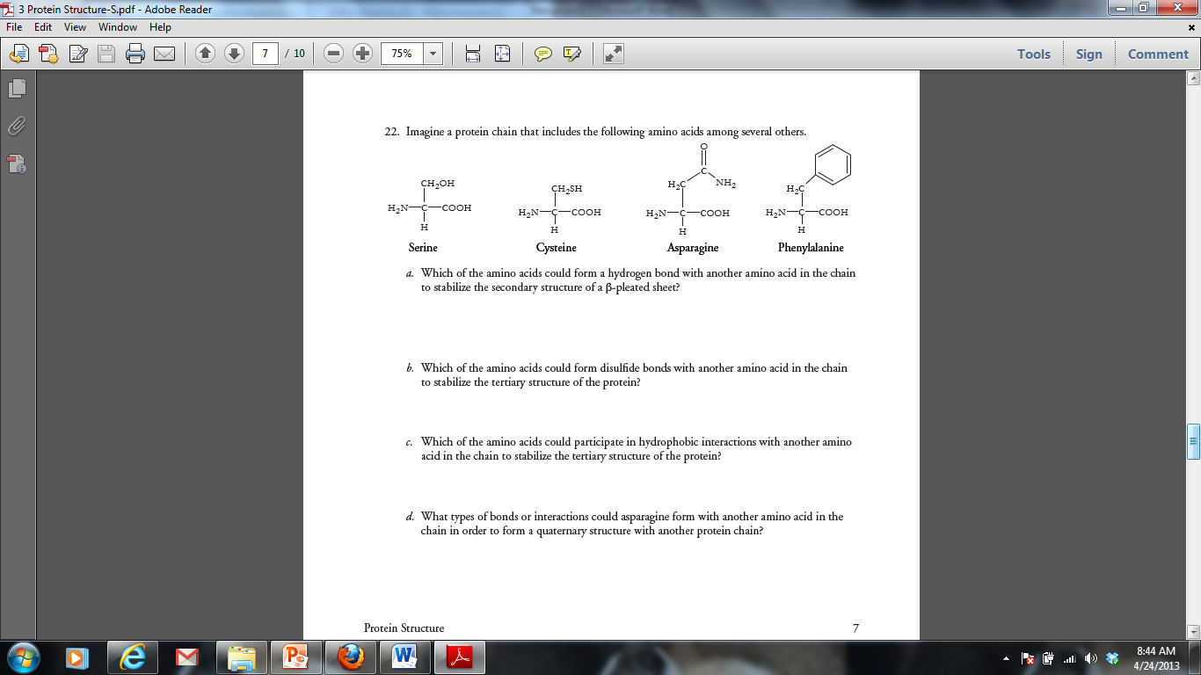

5.

**Biochemistry – Short Free Response (4 points)**

Water is importan t for all living organisms. The functions of water are directly related to its physical properties. Describe how the properties of water contribute to TWO of the following:

* Transpiration
* thermoregulation in endotherms
* plasma membrane structure

**CONCEPT 2 - CELLS**

1. Prokaryotic (Bacteria) Eukaryotic (all other living things)

no membrane-bound organelles m.b.o, ex. Chloroplasts and nucleus

no nucleus(single; circular DNA) multiple linear DNA

free ribosomes and cell wall histones on DNA

1. Cell organelles
2. Nucleus- holds DNA and nucleolus(where ribosomal subunits are made)
3. Mitochondria- double membrane; outer is smooth and inside is folded with enzymes to make ATP (site of cellular respiration (glucose breakdown)
4. Ribosome- site of translation- protein synthesis; made of rRNA and protein
5. E.R.- connected to nucleus; allows for reactions, membranous; smooth= lipids; rough=proteins
6. Golgi complex- packaging in membrane and signals for export
7. Cytoskeleton: Microfilaments- contractile protein, gives shape, movement within cell; Microtubules- centrioles, cilia, flagella, spindle fibers
8. vacuoles/vesicles- water and solutes; large and central in plants
9. ANIMAL

* Lysosomes- contain enzymes; used for intracellular digestion and apoptosis
* Centrioles- used in cell division

1. PLANT

* Chloroplast- double membrane; site of photosynthesis (glucose synthesis)
* Cell wall- middle lamella- pectin; primary cell wall- cellulose; secondary cell wall- lignin

1. Endosymbiont theory- all eukaryotic cells came from bacterial cells that lived together; proof= all chloroplasts and mitochondria have own DNA and are autonomous
2. Cell membrane (separates the internal environment of cell from external environment).
3. Phospholipid bilayer (selectively permeable; amphipathic)
4. Fluid mosaic model (in motion; proteins, cholesterol, glycoproteins and glycolipids among phospholipids). Membrane is hydrophilic on inside and outside, hydrophobic within membrane
5. Simple diffusion- from high to low concentration- small and uncharged move freely through phospholipids ex. CO2, O2 (passive; no energy; no protein carrier)
6. Facilitated diffusion- large or charged from high to low, passive; with protein carrier: ex. glucose, K+
7. Active transport- from low to high concentration; uses ATP; uses a protein
8. Endocytosis- phagocytosis (solid) and pinocytosis (liquid); membrane surrounds and forms vesicles; receptor mediated endocytosis has receptors on surface
9. Exocytosis- release of material using vesicles fusing with membrane
10. Osmosis- diffusion of water using a selectively permeable membrane; passive; no proteins
11. Water potential= pressure potential plus pressure potential; water moves from high water potential to low water potential; solutes always lower water potential; pressure can increase or decrease depending on if it is negative or positive.
12. Plant cells have pressure related to cell wall and vacuole; turgor pressure
13. Hypertonic (high solute), hypotonic (low solute), and isotonic solutions(equal concentration)
14. High surface area : volume ratio increases rate at which food can be taken in a waste expelled
15. Nervous System
16. function: sensory input, motor function, regulation
17. structure: neuron, axon, dendrites, synapse
18. Polarized neuron: Na+ outside, K+ and Cl- inside
19. Depolarization moves Na into neuron, generating an action potential
20. Repolarization exchanges Na+ and K+ through the sodium-potassium pump
21. At synapse, calcium channels open to allow calcium to rush in, stimulating release of neurotransmitters
22. Neurotransmitters released into synapse to generate action potential for motor neuron or muscle cell

***Vocabulary***

active transport

amphipathic

apoptosis

aquaporin

axon

carrier protein

cell wall

centrioles

channel protein

chloroplast

concentration gradient

cytoplasm

cytoskeleton

dendrites

depolarization

diffusion

endocytosis

endoplasmic reticulum

Golgi apparatus

hypertonic

hypotonic

isotonic

ligand

lysosome

membrane

mitochondrion

neuron

neurotransmitter

nuclear envelope

phospholipid

plasma membrane

plasmolysis

polarization

prokaryotic cell

repolarization

ribosome

rough ER

selectively permeable

smooth ER

synapse

exocytosis

eukaryotic cell

facilitated diffusion

flagella

fluid mosaic model

nucleus

organelles

osmosis

passive transport

phagocytosis

surface area:volume ratio

transmembrane protein

vacuole

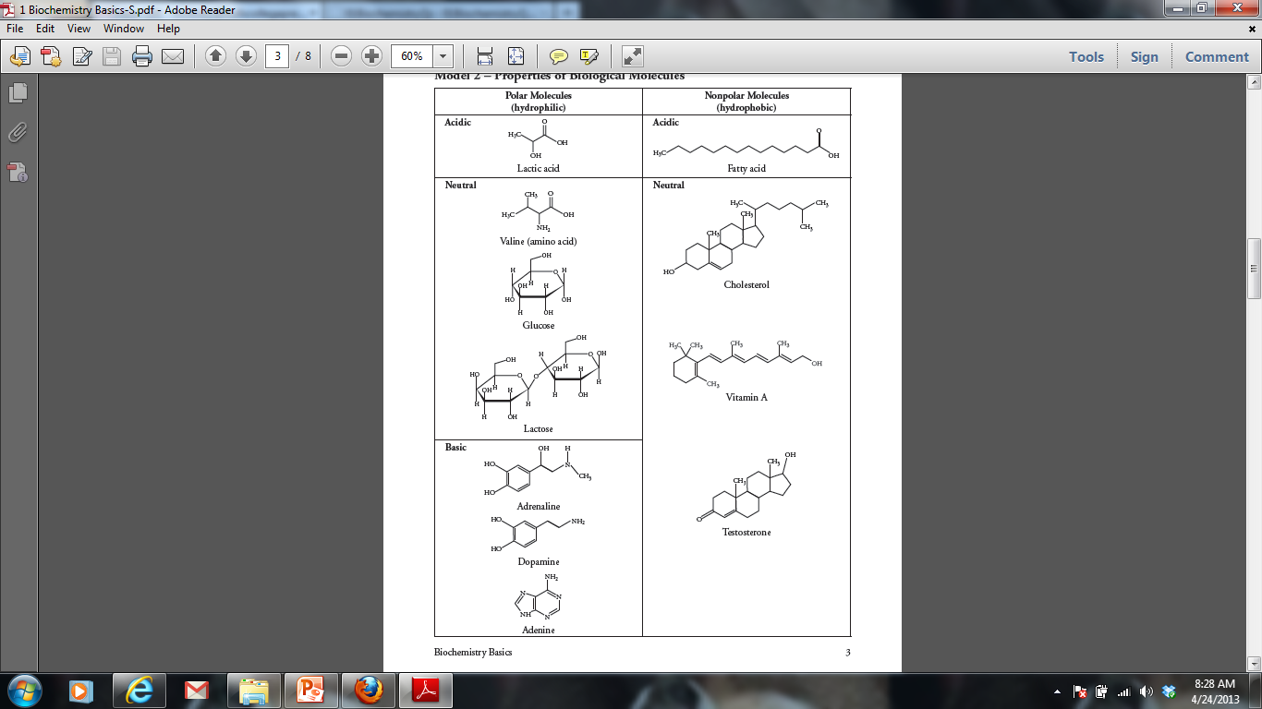***Thinking Practice***

1. For each molecule shown to the right, answer the following, providing justifications for each:
2. Is it polar or nonpolar?
3. Is it hydrophobic or hydrophilic?
4. In order to be transferred into a cell, would the molecule require a protein channel?
5. Biological systems rely heavily on the properties of water movement. Excretion, digestion, and blood pressure are just a few examples of situations where water balance is important. Suppose you have a semi-permeable membrane that ONLY water can pass. On one side of the membrane you have 0.1 M CaCl2. On the other side of the membrane, you have 0.1 M Glucose. CaCl2 ionizes in water to produce 3 ions. Glucose does not ionize in water.

|  |  |
| --- | --- |
| 0.1 M CaCl2 | 0.1 M Glucose |

1. Calculate the water potential for each side of the membrane.
2. Describe which way water will move and explain your answer.

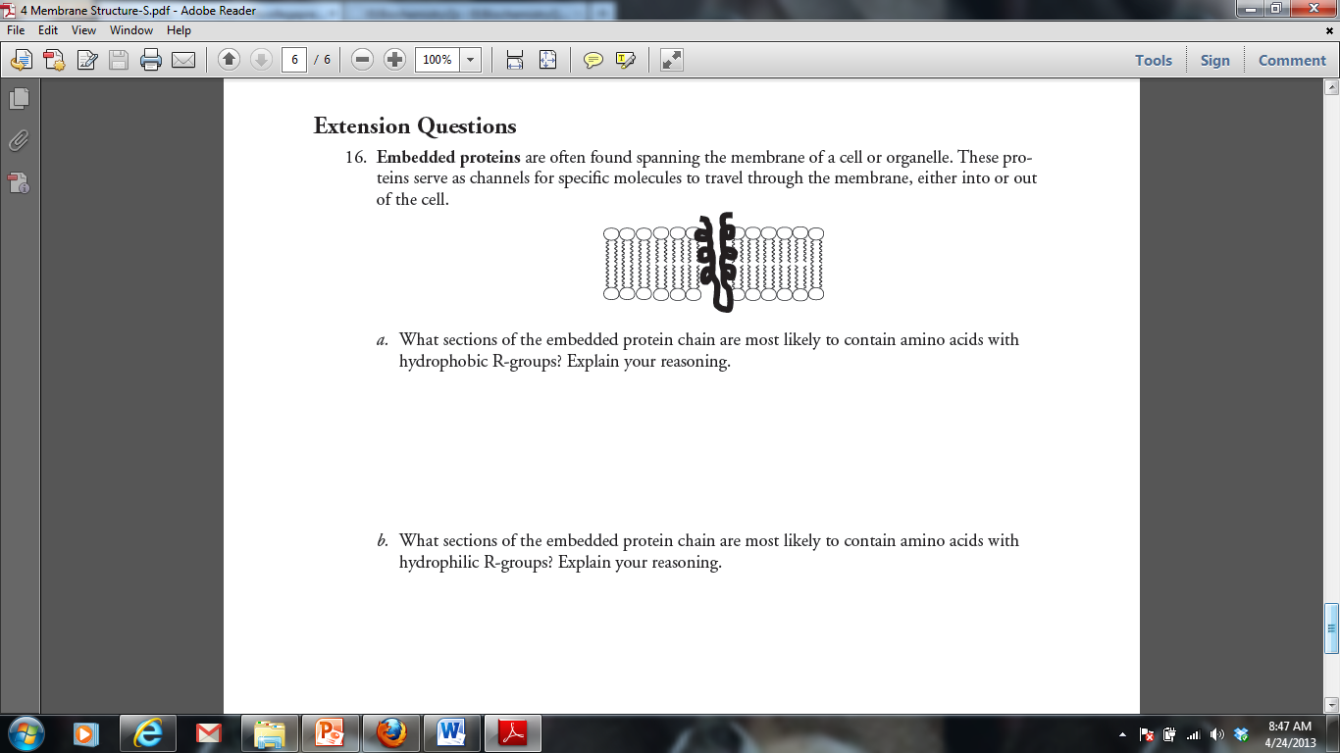

3.



1. The following diagram shows an action potential of a neuron. For each question, you can answer with one letter or multiple letters.
2. At which letters would you find Na+ voltage gated channel OPEN?
3. At which letter(s) would you find the Na+/K+

pump WORKING?

1. At which letter(s) would you find K+ voltage gated channels OPEN?
2. At point F, would there be a more positive charge on the INSIDE or OUTSIDE of the neuron?
3. At point B, would you find more Na+ on the INSIDE or OUTSIDE of the neuron?
4. Tetrodotoxin is a neurotoxin that blocks Na+ voltage gated channels. How would the function of the neuron be altered by the presence of this toxin?
5. Tay-Sachs disease is a human genetic abnormality that results in cells accumulating and becoming clogged with very large and complex lipids. Which cellular organelle must be involved in this condition?

**Cells – Long Free Response (10 points)**

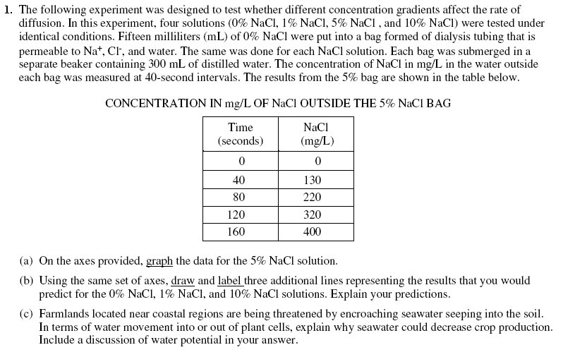

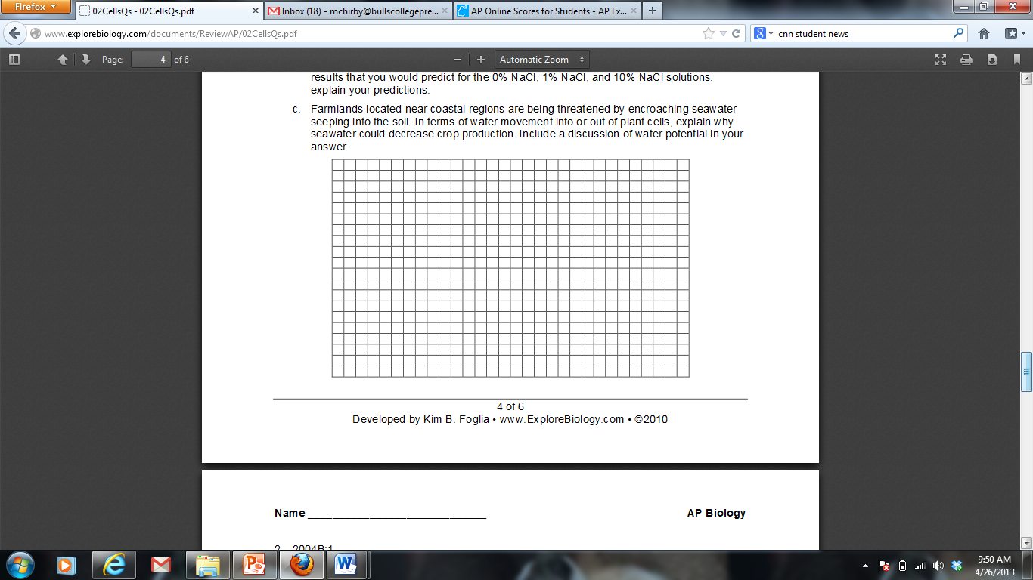

**CONCEPT 3 – ENERGY AND METABOLISM**

1. Energy
2. Organisms use free energy for organization, growth and reproduction. Loss of order or free energy flow results in death.
3. More free energy (ex. Food) than needed will be stored for growth (roots, glycogen, fat, etc.).
4. Matter and energy are not created but change form (1st law of thermo; ex. Sun energy to bond energy in glucose) and entropy is increasing in disorganization of energy (i.e. heat released by cell respiration). More organized or built up compounds have more free energy and less entropy (i.e. glucose) and less organized have less free energy and more entropy (i.e. carbon dioxide).
5. Reactions can be coupled to maintain a system, ex. Photosynthesis and cell respiration
6. Cellular respiration C6H12O6 + 6O2🡪6CO2 + 6H2O
7. Makes ATP for cell use; uses glucose and oxygen makes waste products of carbon dioxide and water; occurs in mitochondria; NADH is electron carrier used
8. Glycolysis
9. occurs in cytoplasm; anaerobic
10. rearranges the bonds in glucose molecules, releasing free energy to form ATP from ADP through substrate-level phosphorylation resulting in the production of pyruvate.
11. Kreb’s cycle
12. occurs in mitochondrial matrix
13. also called the citric acid cycle
14. occurs twice per molecule of glucose
15. Pyruvate is oxidized further and carbon dioxide is released ; ATP is synthesized from ADP and inorganic phosphate via substrate level phosphorylation and electrons are captured by coenzymes (NAD+ and FAD).
16. NADH and FADH2 carry electrons to the electron transport chain.
17. Electron Transport Chain and Chemiosmosis
18. The electron transport chain captures electrons, pumping H+ ions into the inter-membrane space of the mitochondria.
19. Electrons are accepted by O2 molecule forming H2O
20. Concentration of H+ builds up within inter-membrane space lowering the pH and ions rush through ATP synthase into the mitochondria matrix. Rush of ions “spins” ATP synthase protein, causing ADP and Pi to join forming ATP by oxidative phosphorylation
21. Photosynthesis 6CO2 + 6H2O 🡪C6H12O6 + 6O2
22. Photosynthetic organisms capture free energy present in sunlight and use water and carbon dioxide to make carbon products and free oxygen.
23. Light-dependent reactions- photophosphorylation
24. Photosystems I and II (chlorophyll and proteins) are embedded in the internal membranes of chloroplasts (thylakoids of the grana). They pass electrons through an electron transport chain (ETC). When electrons are passed they allow hydrogen ions (protons) across the thykaloid membrane. The formation of the proton gradient powers the process of ATP synthesis to add a phosphate ADP to ATP (chemiosmosis).
25. Electrons are passed to NADP+ to make NADPH (electron carrier)
26. H2O is used and O2 released as by-product
27. Red and blue light works best (green is reflected typically)
28. Energy converted from sun into chemical energy of ATP and NADPH to be used in building of sugar (Calvin Cycle)
29. Light-independent reactions- Calvin Cycle
30. carbon fixation occurs (carbons of CO2 used to make sugar)
31. occurs in stroma of chloroplasts
32. ATP and NADPH generated by light-dependent reactions are used to assemble glucose
33. Anaerobic Fermentation
34. No oxygen; cell only goes through glycolysis followed by fermentation
35. Fermentation recycles NAD needed to restart glycolysis
36. alcohol fermentation ex. yeast cells- glucose 🡪 ethyl alcohol + CO2+ NAD+
37. lactic acid fermentation ex. muscle cells- glucose 🡪 lactic acid + NAD+
38. Fermentation does not make ATP but glycolysis does- 2ATP; very inefficient; sufficient for microorganisms

***Vocabulary***

absorption spectrum

acetyl coA

anabolism

anaerobic metabolism

ATP

ATP synthase

autotroph

Calvin cycle

cellular respiration

chemiosmosis

chlorophyll

chloroplast

citric acid/Krebs cycle

electron transport chain

FAD/FADH2

feedback inhibition

fermentation

glycolysis

light dependent reactions

light independent reactions

metabolic pathway

mitochondrion

NAD/NADH

NADP/NADH

oxidative phosphorylation

photolysis

photosynthesis

photosystem I

photosystem II

pyruvate

stroma

substrate-level phosphorylation

thylakoid membrane

***Thinking Questions***

1. The figure below outlines the process of cellular respiration. Glucose and oxygen are both reactants in this process.
2. Describe the journey of a single carbon atom from glucose in cellular respiration
3. Describe the journey of a single hydrogen atom from glucose in cellular respiration
4. Describe the function of the oxygen molecules in cellular respiration

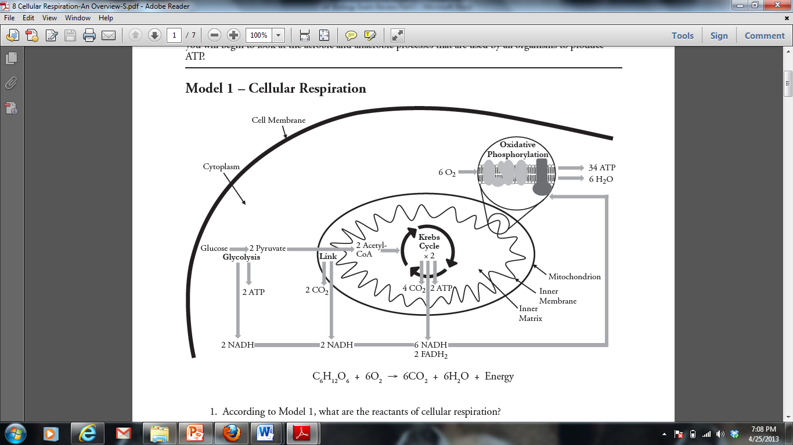

1. The figure below outlines the process of photosynthesis. Carbon dioxide and water are both reactants in this process.
2. Describe the journey of a single hydrogen atom from water in photosynthesis.
3. Describe the journey of a single oxygen atom from water in photosynthesis.
4. Describe the journey of a carbon dioxide molecule in photosynthesis.

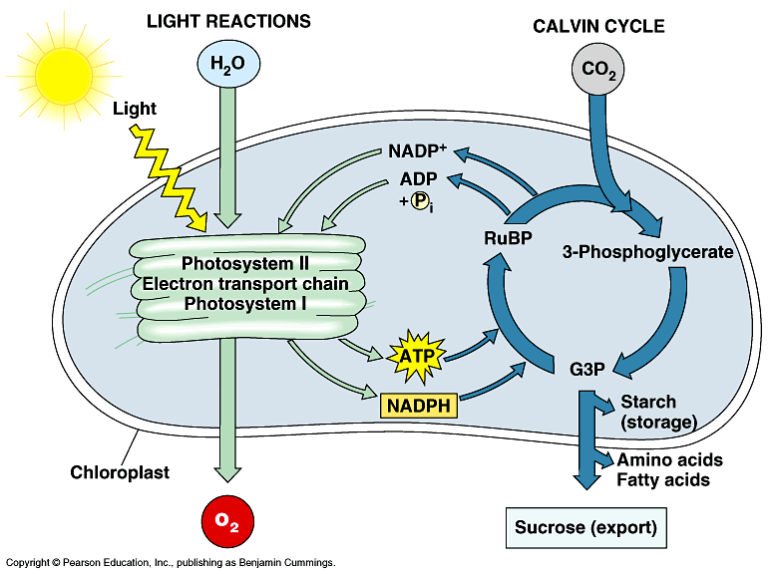

1. It is estimated that more than 2 × 1026 molecules of ATP are hydrolyzed in the human body daily. If each molecule was used only once you would need approximately 160 kg (350 lbs) of ATP daily. The repeated use of ATP molecules through the ATP cycle saves the body a huge amount of resources and energy.

ATP is synthesized in two ways:

* **Substrate-level phosphorylation**—Energy released during a reaction, such as the breakdown of sugar molecules, is used directly to synthesize ATP. A small amount of energy is generated through this process.
* **Electron transfer (oxidative phosphorylation)**—Energy from the movement of electrons from one molecule to another, via electron carriers, is used to synthesize ATP. Most cellular ATP is synthesized by electron transfer in the mitochondria.

Dinitrophenol (DNP) is an “uncoupler,” which means it interferes with the flow of electrons during electron transfer. Fifty years ago, DNP was given as a drug to help patients lose weight.

1. Why would taking DNP make someone lose weight?
2. Why would taking DNP be dangerous?
3. An experiment to measure the rate of respiration in crickets and mice at 10oC and 25o C was performed using a respirometer, an apparatus that measures changes in gas volume. Respiration was measured in mL of O2 consumed per gram of organism over several five-minute trials and the following data were obtained.

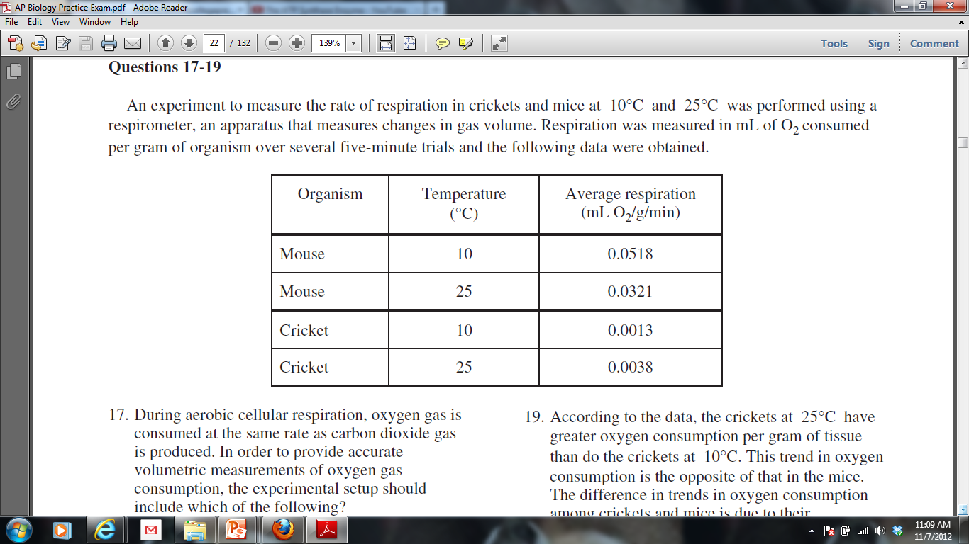

1. Which organism at which temperature had the fastest metabolic rate (produced the most ATP) during its trials? Explain how you know.
2. According to the data, the mice at 10oC demonstrated greater oxygen consumption per gram of tissue than did the mice at 25oC. Propose an explanation for why this is.
3. Under laboratory conditions, muscle cells were broken up and separated into fractions of mitochondria and cytoplasm in an attempt to learn more about cellular respiration. Each fraction was incubated with glucose or pyruvate. Tests were carried out during incubation for the presence of either carbon dioxide or lactic acid. The results are shown below:

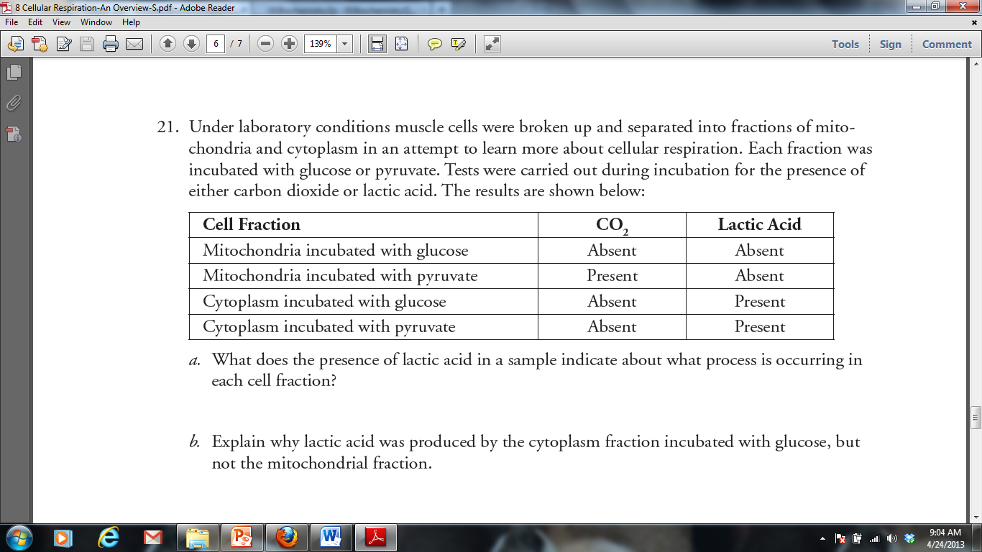

1. What does the presence of lactic acid in a sample indicate about what process is occurring in each cell fraction?
2. Explain why lactic acid was produced by the cytoplasm fraction incubated with glucose, but not the mitochondrial fraction.
3. Why was no carbon dioxide produced by either fraction incubated with glucose?
4. Why did the cytoplasm fraction produce lactic acid in the presence of both glucose and pyruvate?
5. Why did the mitochondria produce carbon dioxide in the presence of pyruvate but not in the presence of glucose?

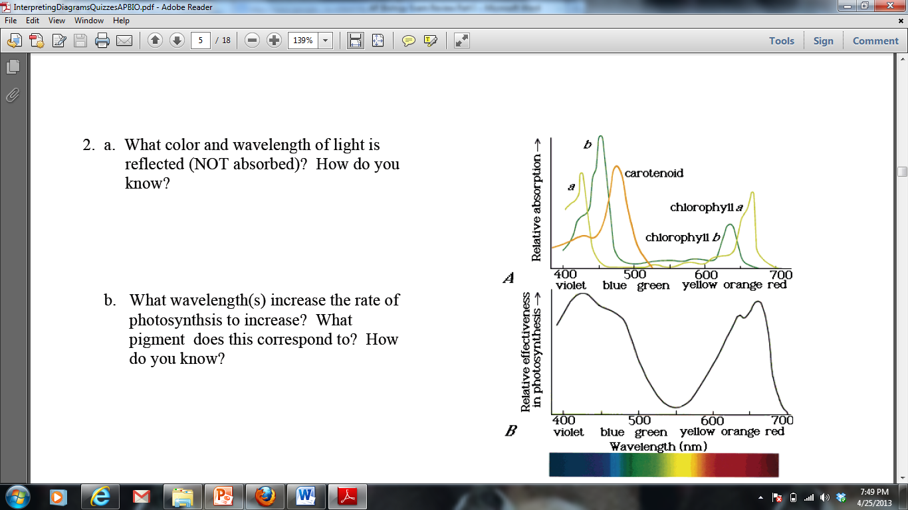

1. The figures to the right display the absorption range for several different pigments found in plants (top) and the rate of photosynthesis at varying conditions of wavelength in one plant species (bottom):
2. What color and wavelength of light is reflected by the plant species tested? How do you know?
3. What wavelength(s) increase the rate of photosynthesis in the plant species tested? What pigment does this correspond to? How do you know?

**Energy and Metabolism Short Free Response (4 points)**

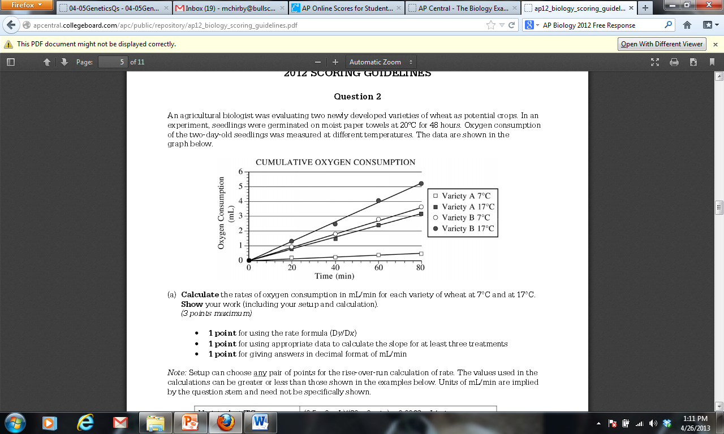

In a second experiment, Variety A seedlings at 17oC were treated with a chemical that prevents NADH from being oxidized to NAD+. **Predict** the most likely effect of the chemical on metabolism and oxygen consumption of the treated seedlings. **Explain** your prediction.

**CONCEPT 4 – THE CELL CYCLE AND HEREDITY**

1. Cell cycle
2. Reason for division- as cells increase in volume, the surface area decreases and demand for material resources increases which limits cell size
3. Smaller cells have a more favorable surface area-to-volume ratio for exchange of materials with the environment (diffusion, etc.). High SA:V ratio is favorable. Ex. 6:1 is better than 6:5
4. Cell cycle switches between interphase and cell division.
5. Interphase has three phases: growth (G1), synthesis of DNA (S) and preparation for mitosis (G2).
6. During mitosis duplicated chromosomes line up in center with spindle fibers attached to help pull them apart. Duplicated chromosomes are pulled apart by spindle fibers.
7. Cytokinesis-division of cytoplasm and reformation of cell membrane. Animal cell- pinches in (cleavage) using microfilaments; plant cell- form cell plate reforms cell wall.
8. The cell cycle is directed by internal controls or checkpoints. Internal (enzymes and promoting factors) and external signals (growth factors) provide stop and- go signs at the checkpoints. Ex. Mitosis-promoting factor (MPF)
9. Cancer results from disruptions in cell cycle control (too much division, defective tumor suppressor genes, overactive genes) which are a result of DNA damage to proto-oncogenes (regulatory genes) which make products like cyclins and cyclin-dependent kinases.
10. Cells spend different amounts of time in interphase or division. Nondividing cells may exit the cell cycle; or hold at a particular stage in the cell cycle.
11. Mitosis is used for growth and repair in animals; plants use mitosis to make gametes and for growth or repair.
12. Mitosis usually begins with 1 cell, makes 2 identical cells or clones; maintains chromosome number; 1n🡪1n or 2n🡪2n.
13. Meiosis (occurs after interphase) takes diploid cells and reduces the chromosome number to haploid. 2n🡪1n.
14. During meiosis, homologous chromosomes are paired (one from mom and one from dad) and line up in the center of the cell randomly. The homologues are pulled apart and separated in meiosis I. A second division occurs in which the duplicated chromosomes are pulled apart.
15. Variation occurs in gametes during “crossing over,” and fertilization because of all possible combinations of homologous chromosomes aligning during metaphase I.
16. Mendel’s Laws (remember he laid groundwork for genetics but these rules can all be broken looking at chromosome theory and molecular genetics)
17. Law of Dominance- one allele will be expressed over another (ex. Aa – if big A is purple it will be seen over little a which is white)
18. Law of Segregation- alleles pairs separate from each other during meiosis
19. Law of Independent Assortment- alleles assort independently during meiosis IF they are on separate chromosomes (i.e. AaBb can make gametes AB, Ab, aB or ab)
20. Probability, Patterns and Exceptions to Mendel’s Rules
21. product rule- multiply chance of one event happening by the chance of another event happening to get the chance of both events occurring together
22. autosomal vs. sex-linked (on the X or Y chromosome)
23. monohybrid cross; one trait; 3:1 (Aa x Aa); 1:1 (Aa x aa) or 4:1 (AA x_), (aa x aa)
24. dihybrid cross; 9:3:3:1 genotype (AaBb x AaBb) or test cross 1:1:1:1(AaBb x aabb)
25. Thomas Hunt Morgan- fruit flies, X- linked traits
26. male- heterozygous XY; Y chromosome is very small in mammals and fruit flies with few genes
27. female- homozygous XX
28. single gene mutations on X chromosome cause disease such as hemophilia or colorblindness
29. sex limited traits are dependent on sex of individual like milk production or male patterned baldness
30. incomplete dominance- red X white 🡪 pink; both protein product are expressed and blended
31. codominance- red x white 🡪 red and white; both protein products are equally expressed ex.AB blood types
32. epistasis- one gene affects expression of another
33. linked genes- genes on same chromosome that are inherited together (can be unlinked by crossing over); recombination frequency calculated by recombinants/total; used for chromosome mapping; genes further apart cross over more often
34. gene/environment- phenotypes affect by environment, Siamese cat, flower color with soil pH, seasonal color in arctic animals, human height and weight
35. polygenic- continuous variation, many genes affect one trait- height, color
36. Human Genetics
37. karyotype- 22 pair autosomes & 1 pair sex chromosomes + 46 total chromosomes
38. Chromosomal Mutations (occur during gamete formation)
39. deletion, inversion, addition of genes as a result of crossing over mistakes
40. chromosomal number abnormalities 🡪 nondisjunction is failure of chromosomes to separate at anaphase of meiosis

***Vocabulary***

anaphase

autosomal

cancer

cell cycle

cell division

centrioles

chromosome

codominance

crossing over

crossover frequency

cyclin-dependent kinase

cytokinesis

diploid (2N)

dominant

F1/F2 Generation

fertilization

gamete

genotype

haploid (1N)

heterozygous

homozygous

incomplete dominance

independent assortment

homologous chromosomes

independent assortment

interphase

meiosis

metaphase

mitosis

nuclear division

phenotype

prophase

recessive

recombination

segregation

sex chromosome

sex-linked

somatic cell

synapsis

synthesis

telophase

***Thinking Practice***

1. Refer to the figure to the right.
2. What process is being shown in this picture?
3. What type of organism are these cells from? How do you know?
4. Identify a numbered cell for each of the four major stages of mitosis.
5. In what stage are most of the cells in this image? What does this indicate about the amount of time spent in each phase of the cell cycle?
6. Paclitaxel is a chemotherapy drug used to treat a variety of cancers. Paclitaxel inhibits both assembly and disassembly of microtubules.
7. Which phase in the cell cycle is affected by Paclitaxel? How does this drug inhibit the growth of cancer?
8. Paclitaxel affects not only cancer cells, but normal cells as well. Would the effects of Paclitaxel be seen first in organs that have quickly dividing cells (like the intestine and hair follicles) or in organs that have slow or nondividing cells (like muscles and the nervous system). Justify your reasoning.
9. Two students debate about proteins that regulate the cell cycle. One argues that MPF triggers the production of cyclin, while the other argues that cyclin triggers the production of MPF.
10. Based on the figure to the right, which statement is correct and why?
11. Propose a possible function of MPF, based on when it is produced in the cell cycle.
12. You have performed a dihybrid cross of plants and got the following data: 206 purple tall, 65 white tall, 83 purple short, 30 white short. Perform a chi-square analysis to test the null hypothesis that purple coloring is dominant to white and tall height is dominant to short height.
13. A space probe discovers a planet inhabited by creatures that reproduce with the same hereditary patterns seen in humans. Three of the phenotypic characteristics of these creatures are: height, antennae, and nose morphology. Earth scientists were able to do some controlled breeding experiments with these organisms. 100 males and 100 females were used in the experiments and the results of a number of crosses are shown below. Review this information and use it answer the questions that follow.

**Cross I**: True-breeding (homozygous) tall creatures were crossed with true breeding short creatures. ALL of the F1 were tall. The F1 creatures were crossed and the following data was obtained.

|  |  |  |
| --- | --- | --- |
| F2 Phenotype | Male | Female |
| Tall | 2575 | 2625 |
| Short | 1425 | 1375 |

**Cross II**: True breeding creatures WITH antennae are crossed with true-breeding creatures WITHOUT antennae. ALL of the F1 had antennae. The F1 creatures were crossed and the following data was obtained.

|  |  |  |
| --- | --- | --- |
| F2 Phenotype | Male | Female |
| WITH antennae | 3125 | 3100 |
| WITHOUT antennae | 875 | 900 |

**Cross III**: Creatures that are true breeding for upturned snout are crossed with creatures with down turned snouts. ALL of the F1 offspring had upturned snouts. The F1 creatures were crossed and the following data was obtained.

|  |  |  |
| --- | --- | --- |
| F2 Phenotype | Male | Female |
| Upturned Snout | 1750 | 3475 |
| Down Turned snout | 1750 | 0 |

**Cross IV**: True breeding tall, with antennae creatures were crossed with true breeding short, without antennae creatures. ALL of the F1 offspring were tall, with antennae. These F1 offspring were crossed with true breeding short, without antennae creatures. The F2 data is in the table below.

|  |  |  |
| --- | --- | --- |
| F2 Phenotype | Male | Female |
| Tall, WITH antennae | 2360 | 2220 |
| Tall, WITHOUT antennae | 220 | 300 |
| Short, WITH antennae | 260 | 220 |
| Short, WITHOUT antennae | 2240 | 2180 |

1. What conclusions can be drawn from cross I and II? Explain how the data supports your conclusions (Hint! You might need to do a chi square analysis to support conclusions!)
2. What conclusions can be drawn from cross III? Explain how the data supports your conclusions (Hint! You might need to do a chi square analysis to support conclusions!)
3. What conclusions can be drawn from cross IV? Explain how the data supports your conclusions (Hint! You might need to do a chi square analysis to support conclusions!)

**Cell Cycle and Heredity Short Free Response (5 points)**

Meiosis reduces chromosome number and rearranges genetic information. **Explain** how the reduction and rearrangement are accomplished in meiosis.

**CONCEPT 5 – MOLECULAR GENETICS**

1. DNA Structure
2. Discovery
3. Avery-MacLeod- Marty- 1944 isolated DNA from Griffith’s transformation experiment
4. Hershey-Chase- 1952 elegant experiment with virus and bacteria showing DNA was injected not protein
5. Watson, Crick, Wilkins, and Franklin- 1953 W and C published work showing structure of DNA (used Wilkins and Franklins work to do so)
6. Structure of DNA
7. Deoxyribose nucleic acid
8. Double helix (two twisted stsrands) made of nucleotides (monomers)
9. Nucleotide = phosphate + 5C deoxyribose sugar + nitrogen base
10. Antiparallel strands- one runs 3’ to 5’ the other runs 5’ to 3’,sides of phosphates and sugars (backbone), rungs of paired bases with hydrogen bonds in between
11. Purines (adenine,guanine; double rings) pair with Pyrimidines (cytosine, uracil, thymine; single ring)
12. A - T- double H bond
13. C – G- triple H bond
14. Location
15. In eukaryotes DNA is found in nucleus on multiple linear chromosomes (a chromosome IS a strand of DNA with proteins etc. associated).
16. In prokaryotes DNA is not in a nucleus and is usually a single circular chromosome
17. Prokaryotes, viruses, and eukaryotes (yeast) can contain plasmids (small extra-chromosomal DNA that is double stranded DNA)
18. DNA replication
19. Process of making exact copies of DNA (i.e. for mitosis or meiosis)
20. Process is semi conservative (original strand is copied)
21. Steps
22. Enzyme (helicase) unzip strands by breaking hydrogen bonds
23. “Spare” nucleotides are added bidirectionally to bond complementarily with use of DNA polymerases (DNA pol)
24. DNA pol only can add to the 3’ to 5’ side and new DNA is made in the 5’ to 3’direction
25. Replication bubbles open up and a replication fork is created because bubble is in half and it has one side 3/5 and one 5/3
26. RNA primers must be laid down to start process (RNA primase makes primers)
27. Leading strand makes DNA continuously (3/5)
28. Lagging strand makes DNA discontinuously (5/3), Okazaki fragments
29. Lagging strand requires enzyme (ligase) to fuse fragments
30. RNA
31. Ribonucleic acid
32. Single stranded, different sugar called ribose, different base called uracil INSTEAD of thymine
33. Base pair rules in RNA, A-U and C-G
34. messenger RNA or mRNA carries information from DNA to the ribosome
35. transfer RNA or tRNA bind amino acids and are used in translation at ribosome
36. ribosomal RNA or rRNA are part of ribosomes that have catalytic function
37. RNAi are molucules that are used for regulation of gene expression (turn on or off)
38. Transcription
39. making mRNA in nucleus
40. enzyme RNA pol reads the DNA in 3’ to 5’ direction and synthesizes complementary mRNA
41. Ex. 3’ to 5’ DNA is ATG CAT then the 5’ to 3’ mRNA made will be UAC GUA
42. Steps
43. TATA Box where RNA pol binds and begins
44. Transcription Factors (proteins that enhance transcription and help RNA pol into correct shape)
45. Elongation (adding of RNA nucleotides- does not stay attached to DNA)
46. Termination, ends when RNA pol reaches a termination sequence
47. mRNA editing
48. introns are excised (cut out)
49. exons are left and spliced together using spliceosomes (snRNP’s)
50. add polyA tail to 3’
51. add GTP cap to 5’
52. each 3 are called a codon
53. go to ribosome (free or in RER)
54. Translation
55. mRNA code is read and matched with tRNA (brings amino acids) to construct a polypeptide using the ribosome
56. Ex. mRNA codon is AAA then tRNA anticodon will be UUU and will have a corresponding amino acid for that codon of mRNA
57. Initiation: 5’ end of mRNA attaches to small ribosome, tRNA with anticodon UAC attaches to start codon AUG ; large ribosomal subunit binds and tRNA is in P site
58. Elongation: new tRNA enters A site; peptide bond forms when a.a. is transferred from tRNA in P site to A site; translocation occurs and tRNA in A site moves to P
59. Termination: Ribosome encounters stop codon (UAA, UAG, UGA)
60. If in ER then: polypeptide is released into ER, then to Golgi complex, vesicle to cell membrane, then exocytosis (may be given signals for exit/destination)
61. Free ribosomes typically make products for the cell and are not exported
62. Mutations
63. any change of DNA sequence, can be inheritable if it is in egg or sperm
64. point mutations- one nucleotide error; substitutions (i.e. A instead of G)
65. frame shift mutations- one or more bases deleted or inserted
66. silent mutations can occur, i.e. substitution codes for same a.a. or deletion/insertion is of three nucleotides

***Vocabulary***

amino acids

anticodon

base-pairing rules

cell differentiation

coding strand

codon

DNA

DNA ligase

DNA polymerase

DNA replication

exons

genetic code

helicase

hydrogen bonding

inducible genes

introns

lagging strand

leading strand

micro RNA (miRNA)

mutation

nucleic acids

nucleotides

Okazaki fragments

protein

replication fork

repressor

RNA (mRNA, rRNA, tRNA)

start codon/stop codon

template strand

transcription

transcription factors

translation

***Thinking Questions***

1. Compare the two DNA sequences shown below. Transcribe them into mRNA and translate them into an amino acid sequence.

GTG CAC CTC ACT CCA GAG GAG (Normal Hemoglobin)

mRNA 🡪

amino acids 🡪

GTG CAC CTC ACT CCA GTG GAG (Sickle Cell Hemoglobin)

mRNA 🡪

amino acids 🡪

1. Circle any differences there are in the DNA, RNA and amino acid sequences that might exist between these two sequences.
2. Identify the type of mutation that is represented AND EXPLAIN, IN DETAIL, what effect this would have on the protein/pigment (be sure to mention the types of functional groups on the amino acids and how this would affect shape of the molecule).
3. In prokaryotic cells, translation begins before transcription is finished. Give two reasons why this would not be possible in eukaryotic cells.
4. The restriction enzyme EcoRI cleaves double-stranded DNA at the sequence 5'-GAATTC-3' and the restriction enzyme HindIII cleaves at 5'-AAGCTT-3'. A 20 kb circular plasmid is digested with each enzyme individually and then in combination, and the resulting fragment sizes are determined by means of electrophoresis. The results are as follows:

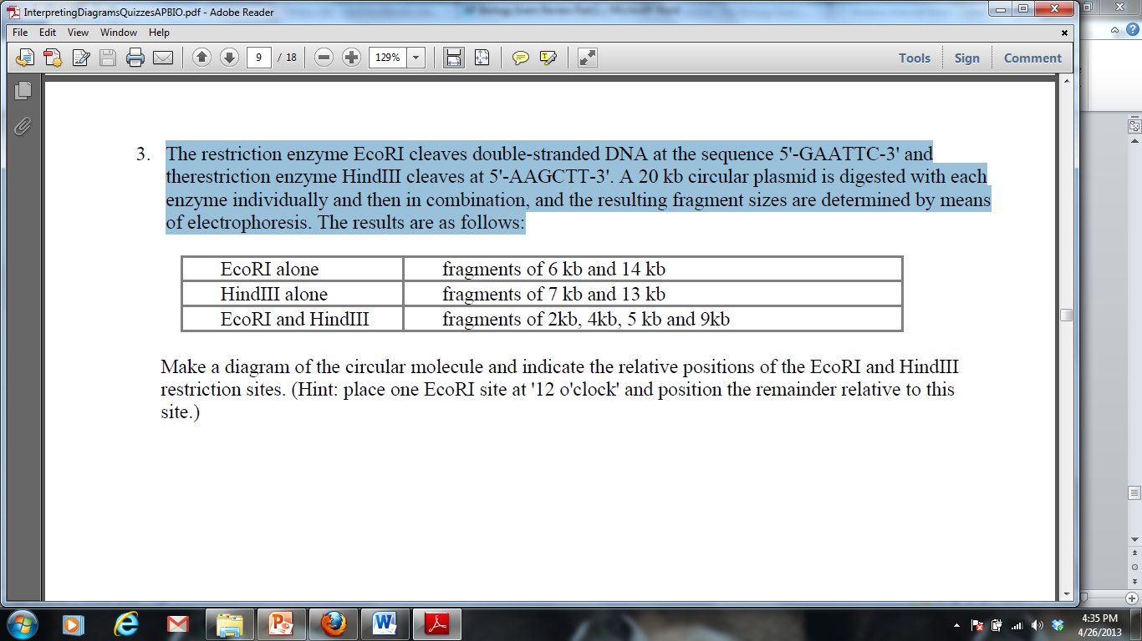

Make a diagram of the circular molecule and indicate the relative positions of the EcoRI and HindIII restriction sites. (Hint: place one EcoRI site at '12 o'clock' and position the remainder relative to this site.)

**Molecular Genetics Short Free Response (4 points)**

When DNA replicates, each strand of the original DNA molecule is used as a template for the synthesis of a second, complementary strand. Compare and contrast the replication of the two new strands, **listing** and **explaining** at least one similarity and one difference in the methods of synthesis. You may draw a diagram to help answer the question, but be sure to explain your diagram in your answer.

**CONCEPT 6 – REGULATION**

1. Feedback
2. Negative feedback mechanisms maintain dynamic homeostasis for a particular condition (variable) by regulating physiological processes, returning the changing condition back to its target set point.
3. Positive feedback mechanisms amplify responses and processes in biological organisms. The condition initiating the response is moved farther away from the initial set-point. Amplification occurs when the stimulus is further activated which, in turn, initiates an additional response that produces system change.
4. Cell-to-cell communication
5. Cells receive or send inhibitory or stimulatory signals from other cells, organisms or the environment.
6. In single-celled organisms it is response to its environment.
7. In multicellular organisms, signal transduction pathways coordinate the activities within individual cells. Ex. Epinephrine stimulation of glycogen breakdown in mammals
8. Cells communicate by cell-to-cell contact. Ex Immune cells interact by cell-cell contact, antigen- presenting cells (APCs), helper T-cells and killer T cells or plasmodesmata between plant cells that allow material to be transported from cell to cell.
9. Cells communicate over short distances by using local regulators that target cells in the vicinity of the emitting cell. Ex. Neurotransmitters, plant immune response
10. Signals released by one cell type can travel long distances to target cells of another cell type. Ex. Hormones
11. A receptor protein recognizes signal molecules, causing the receptor protein’s shape to change, which initiates transduction of the signal. Ex. G-protein linked receptors, ligand-gated ion channels, tyrosine kinase receptors.
12. Signal transduction is the process by which a signal is converted to a cellular response. Signaling cascades relay signals from receptors to cell targets, often amplifying the incoming signals, with the result of appropriate responses by the cell.
13. Second messengers inside of cells are often essential to the function of the cascade.
14. Many signal transduction pathways include: Protein modifications or phosphorylation cascades in which a series of protein kinases add a phosphate group to the next protein in the cascade sequence.
15. Gene Regulation
16. Prokaryotes
17. Inducers (turn genes on) and repressors (turn genes off) are small molecules that interact with regulatory proteins and/or regulatory sequences.
18. Regulatory proteins inhibit gene expression by binding to DNA and blocking transcription (negative control).
19. Regulatory proteins stimulate gene expression by binding to DNA and stimulating transcription (positive control) or binding to repressors to inactivate repressor function.
20. Eukaryotes
21. Transcription factors bind to DNA sequences and other regulatory proteins
22. Some of these transcription factors are activators (increase expression), while others are repressors (decrease expression).
23. The combination of transcription factors binding to the regulatory regions at any one time determines how much, if any, of the gene product will be produced.
24. Immunity
25. Plants, invertebrates and vertebrates have multiple, nonspecific immune responses, ex: phagocytes engulf and digest pathogens with the help of lysosomes
26. Mammals use specific immune responses triggered by natural or artificial agents that disrupt dynamic homeostasis.
27. The mammalian immune system includes two types of specific responses: cell mediated and humoral.
28. In the cell-mediated response, cytotoxic T cells, a type of lymphocytic white blood cell, target‖intracellular pathogens when antigens are displayed on the outside of the cells.
29. In the humoral response, B cells, a type of lymphocytic white blood cell, produce antibodies against specific antigens.
30. Antigens are recognized by antibodies to the antigen.
31. Antibodies are proteins produced by B cells, and each antibody is specific to a particular antigen.
32. A second exposure to an antigen results in a more rapid and enhanced immune response.
33. Viruses
34. Replication
35. Viruses inject DNA or RNA into host cell
36. Viruses have highly efficient replicative capabilities that allow for rapid evolution
37. Viruses replicate via the lytic cycle, allowing one virus to produce many progeny simultaneously
38. Virus replication allows for mutations to occur through usual host pathways.
39. RNA viruses lack replication error-checking mechanisms, and thus have higher rates of mutation.
40. Related viruses can combine/recombine information if they infect the same host cell.
41. Some viruses are able to integrate into the host DNA and establish a latent (lysogenic) infection
42. HIV is a well-studied system where the rapid evolution of a virus within the host contributes to the pathogenicity of viral infection.
43. Genetic information in retroviruses is a special case and has an alternate flow of information: from RNA to DNA, made possible by reverse transcriptase, an enzyme that copies the viral RNA genome into DNA. This DNA integrates into the host genome and becomes transcribed and translated for the assembly of new viral progeny.

***Vocabulary***

Antibody

Antigen

B-cell

Cell-mediated immunity

communication

cyclic AMP (cAMP)

cytotoxic T-cell

G-protein linked receptor

Helper T-cell

Hormone

Humoral immunity

Inducer

Lytic cycle

Lysogenic cycle

Negative feedback

Operon

Operator

Phagocyte

phagocytosis

phosphorylation cascade

positive feedback

protein kinase

receptor

repressor

retrovirus

reverse transcriptase

second messenger

signal cascade

signal transduction

signal transduction pathway

transcription factor

virus

white blood cell

***Thinking Practice***

1. Refer to the diagram at the right to respond to the following questions.
2. Is the hormone hydrophobic or hydrophilic? How do you know?
3. Explain how the action of the hormone might be different if it could move through the cell membrane.
4. Explain what is happening in this picture and make a prediction about what will be the end result in the cell to which this hormone has bound.
5. Lactose digestion in *E. coli* begins with its hydrolysis by the enzyme *b*-galactosidase. The gene encoding *b*-galactosidase, *lacZ*, is part of a coordinately regulated operon containing other genes required for lactose utilization. Use the legend below to draw the gene and its interaction with RNA polymerase, the repressor protein, and lactose when lactose is being digested.

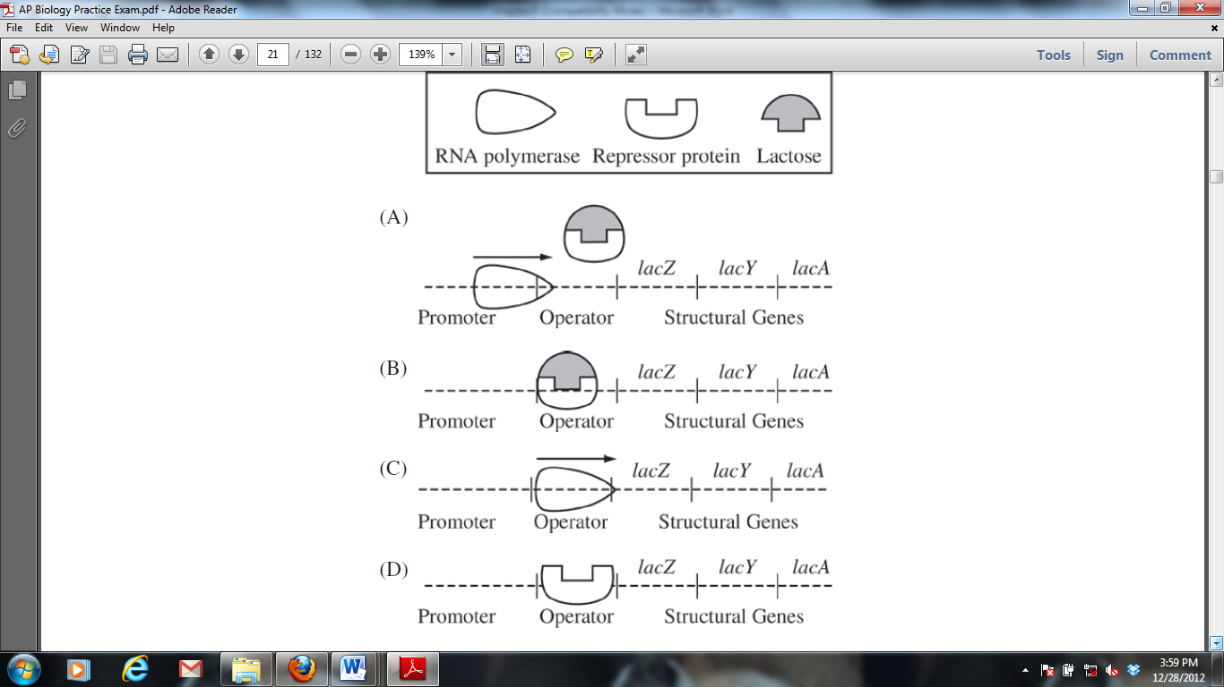



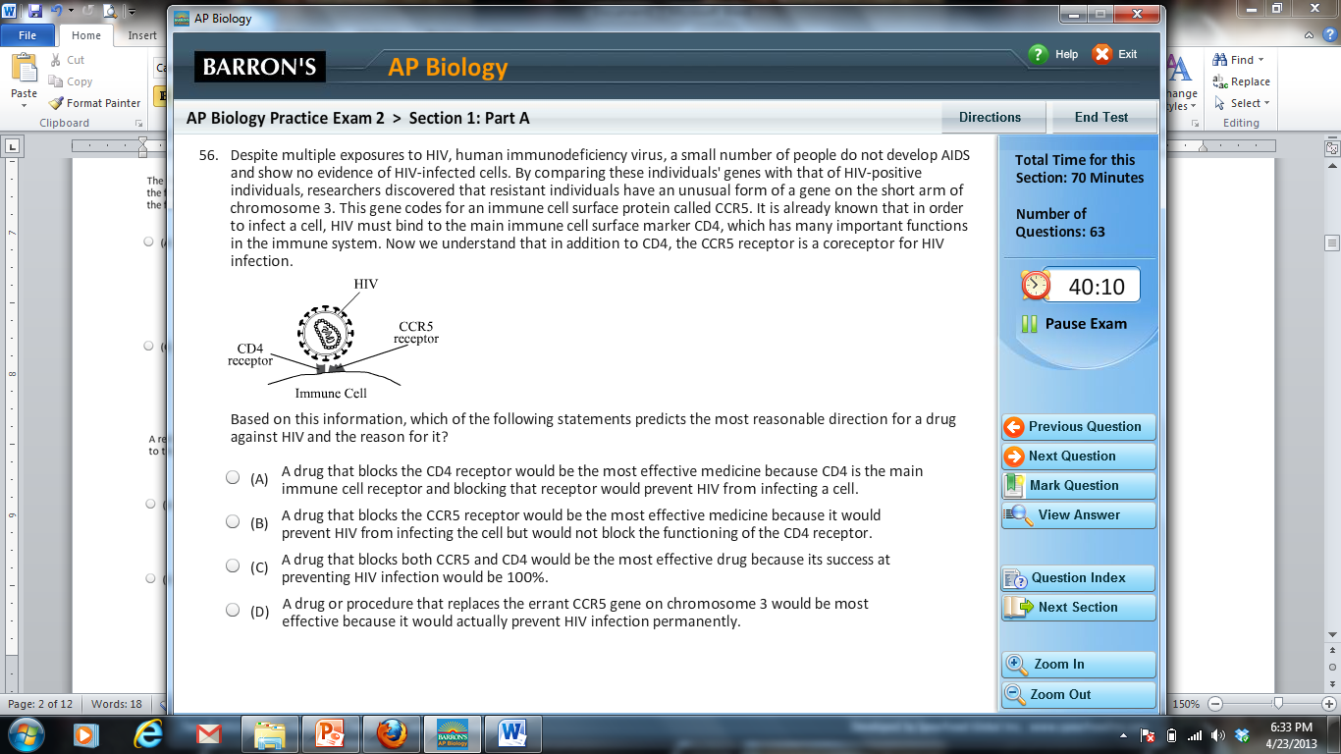

Based on the information provided, propose a possible mechanism for a drug to resist HIV infection.

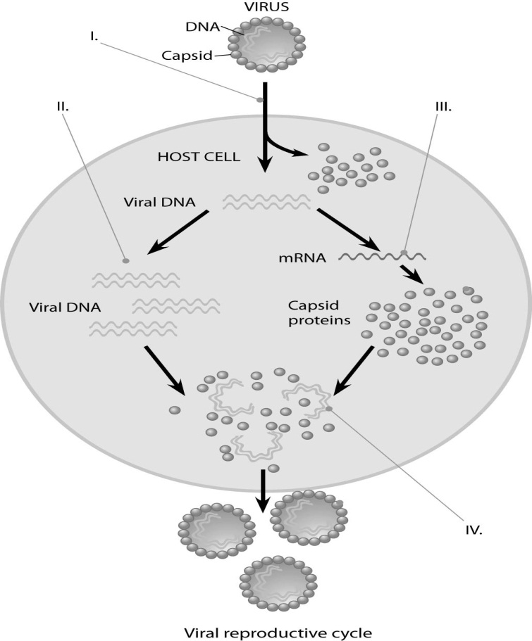

1. Describe the processes occurring at each of the numbered positions (I, II, III, and IV) in the diagram to the right.
2. Refer to the images at the right to answer the following:
3. Which immune response in shown: cell mediated or humoral? Explain how you know.
4. What are the “Y” shaped molecules called? What is their role in the immune response?



1. Describe how the “Y” shaped molecules relate to the graph displayed.
2. One student described an action potential in a neuron by saying “As more gates open the concentration of sodium inside the cell increases and this causes even more gates to open.” Is this an example of a positive or negative feedback loop? Justify your reasoning.



1. The figure to the right shows the feedback mechanism for regulating blood glucose.
2. Is this a positive or negative feedback loop? Explain your answer.
3. Individuals that suffer from Type I diabetes do not have functional insulin-producing cells. Describe how their blood will differ from that of a healthy individual after a glucose-rich meal.
4. In a molecular biology laboratory, a student obtained competent *E. coli* cells and used a common transformation procedure to induce the uptake of plasmid DNA with a gene for resistance to the antibiotic kanamycin. The results below were obtained.

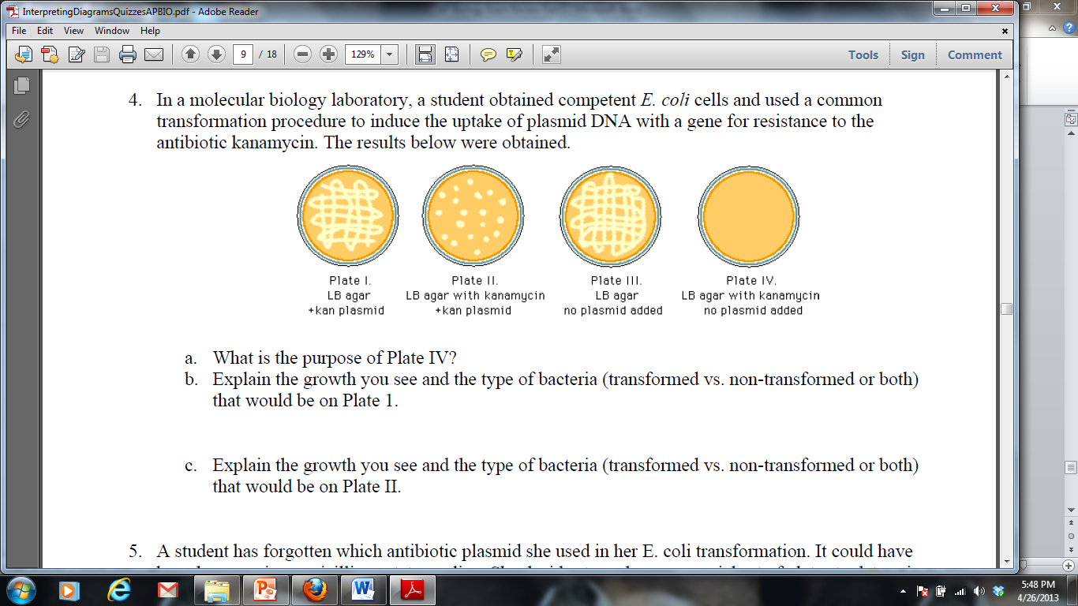

1. What is the purpose of Plate IV?
2. Explain the growth you see and the type of bacteria (transformed vs. non-transformed or both) that would be on Plate 1.
3. Explain the growth you see and the type of bacteria (transformed vs. non-transformed or both) that would be on Plate II.
4. If the student repeated the experiment, but the heat shock was unsuccessful and the plasmid was unable to be transformed, for which plates would growth be expected? Explain your answer.

**CONCEPT 7 – EVOLUTION**

1. Natural Selection
2. Major mechanism of change over time – Darwin’s theory of evolution
3. There is variation among phenotypes – genetic mutations play a role in increasing variation
4. Competition for resources results in differential survival, with individuals with the most favorable traits surviving to reproduce offspring
5. An adaptation is a genetic variation that is favored by selection and is manifested as a trait that provides an advantage to an organism in a particular environment.
6. Fitness is the ability to survive and reproduce
7. Hardy-Weinberg Equilibrium
8. A mathematical model used to calculate changes in allele frequency, providing evidence for the occurrence of evolution in a population.
9. 5 conditions must be met for a population to be in HW equilibrium – conditions are seldom met
10. Large population
11. No migration
12. No mutations
13. Random mating
14. No natural selection
15. Equations
16. p = the frequency of dominant alleles in a population
17. q = the frequency of recessive alleles in a population
18. p2 = the frequency of homozygous dominant individuals in a population
19. q2 = the frequency of homozygous recessive individuals in a population
20. 2pq=the frequency of heterozygous individuals in a population
21. p + q = 1
22. p2 + 2pq + q2 = 1
23. Speciation
24. An evolutionary process by which 2 or more species arise from 1 species and 2 new species can no longer breed and reproduce successfully
25. Many mechanisms by which it can occur
26. Geographic isolation

* Species separated by physical barrier

1. Reproductive isolation

* Different behaviors limit mating
* Different habitats limit mating
* Different mating seasons limit mating
* Different anatomical structures limit mating

1. Can take place over millions of years or rapidly (after extinction events, for example)
2. Evidence for Evolution
3. Fossils can be dated by a variety of methods that provide evidence for evolution. These include the age of the rocks where a fossil is found, the rate of decay of isotopes including carbon-14, the relationships within phylogenetic trees, and the mathematical calculations that take into account information from chemical properties and/or geographical data.
4. Morphological homologies represent features shared by common ancestry. Vestigial structures are remnants of functional structures, which can be compared to fossils and provide evidence for evolution.
5. Biochemical and genetic similarities, in particular DNA nucleotide and protein sequences, provide evidence for evolution and ancestry.
6. Origin of Life
7. Primitive Earth provided inorganic precursors from which organic molecules could have been synthesized due to the presence of available free energy and the absence of a significant quantity of oxygen.
8. Chemical experiments have shown that it is possible to form complex organic molecules from inorganic molecules in the absence of life.
9. These complex reaction sets could have occurred in solution (organic soup model) or as reactions on solid reactive surfaces.
10. The RNA World hypothesis proposes that RNA could have been the earliest genetic material.
11. Phylogenetic Trees
12. Phylogenetic trees and cladograms can represent traits that are either derived or lost due to evolution.
13. Phylogenetic trees and cladograms illustrate speciation that has occurred, in that relatedness of any two groups on the tree is shown by how recently two groups had a common ancestor.
14. Phylogenetic trees and cladograms can be constructed from morphological similarities of living or fossil species, and from DNA and protein sequence similarities.
15. Phylogenetic trees and cladograms are dynamic, constantly changing due to current and emerging knowledge.

***Vocabulary***

Adaptation

Bottleneck Effect

Common Ancestor

Cladogram

Evolution

Gene Flow

Gene Pool

Genetic Drift

Geographic Isolation

Fitness

Hardy-Weinberg Equilibrium

Natural Selection

Morphology

Phylogenetic Tree

Reproductive Isolation

Speciation

Variation

***Thinking Questions***

1. As a field researcher you are sent to the Arizona desert to study the prairie dog species C. ludivincianus to determine if the population is in Hardy-Weinberg equilibrium. Specifically, you are studying this population with respect to the gene that determines the coat color in C. ludivincianus. This trait is coded for by a single gene (the NDY6 gene) with two alleles (N, n) and is passed down from one generation to the next. After sampling 170 of these prairie dogs, you find that 36% of the C. ludivincianus population is homozygous recessive for coat color. Assuming that the population is in Hardy-Weinberg equilibrium…
2. What is the allele frequency of the N allele?
3. What is the frequency of homozygous dominant prairie dogs?
4. What is the frequency of heterozygous prairie dogs?
5. What conditions must be being satisfied?
6. Sixty flowering plants are planted in a flowerbed. Forty of the plants are red-flowering homozygous dominant. Twenty of the plants are white-flowering homozygous recessive. The plants naturally pollinate and reseed themselves for several years. In a subsequent year, 178 red-flowered plants, 190 pink-flowered plants, and 52 white-flowered plants are found in the flowerbed. Use a chi-square analysis to determine if the population is in Hardy-Weinberg equilibrium.
7. For the past 10 to 25 years, farmers have planted crop seeds that have been genetically modified to withstand treatment with a common weed killer called Roundup®. This allows the farmers to spray their fields to get rid of weeds without harming their crops. Recently, more and more farmers have discovered that their fields have Roundup-resistant pigweed growing along with their crop. Describe what has most likely happened over time to lead to this.
8. Peppered moths have wings that vary in color, ranging from white to dark gray. During the Industrial Revolution through the mid-20th century, factories and power plants, which burned coal, produced large quantities of soot and smog. Near industrialized areas, black powder covered surfaces, including the moth habitat.
9. Use this information to explain the changes seen in light and dark peppered moths from 1800-1950, as shown in the graph below.

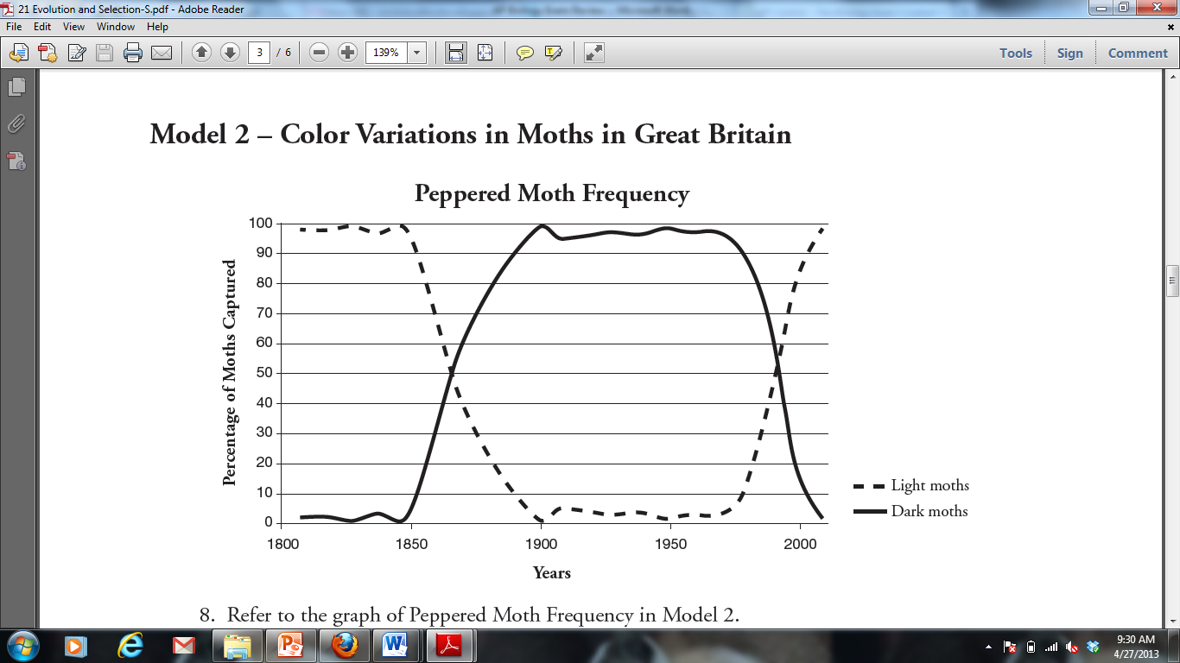

1. Propose an explanation for the return of the peppered moth population to more light than dark moths by the year 2000.
2. Five new species of bacteria were discovered in Antarctic ice core samples. The nucleotide (base) sequences of rRNA subunits were determined for the new species. The table below shows the number of nucleotide differences between the species. Draw a phylogenetic tree indicating the relatedness of these 5 species.

|  |  |  |  |  |  |
| --- | --- | --- | --- | --- | --- |
| Species | 1 | 2 | 3 | 4 | 5 |
| 1 | - | 2 | 23 | 19 | 17 |
| 2 |  | - | 24 | 19 | 18 |
| 3 |  |  | - | 23 | 23 |
| 4 |  |  |  | - | 1 |
| 5 |  |  |  |  | - |



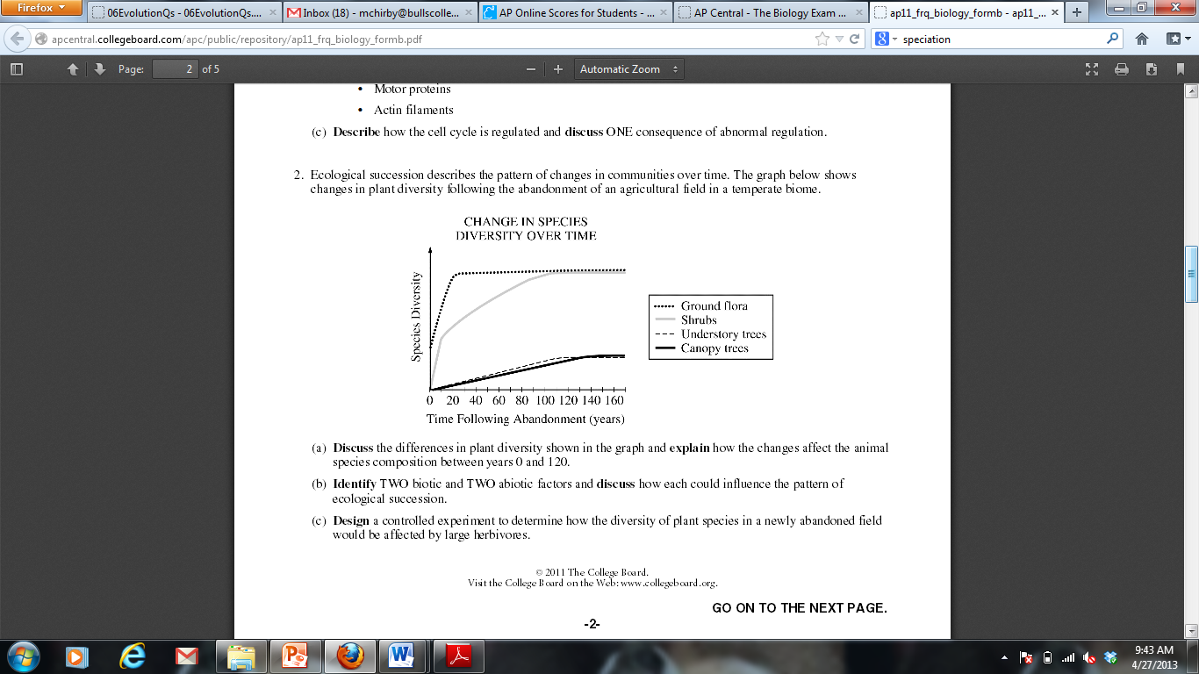

1. Discuss the differences in diversity among the plants shown in the graph.
2. If a scientist wanted to determine if two understory trees in the field were the same species, what pieces of evidence would she gather and how would these inform her conclusion?

**Evolution Long Free Response (10 points)**

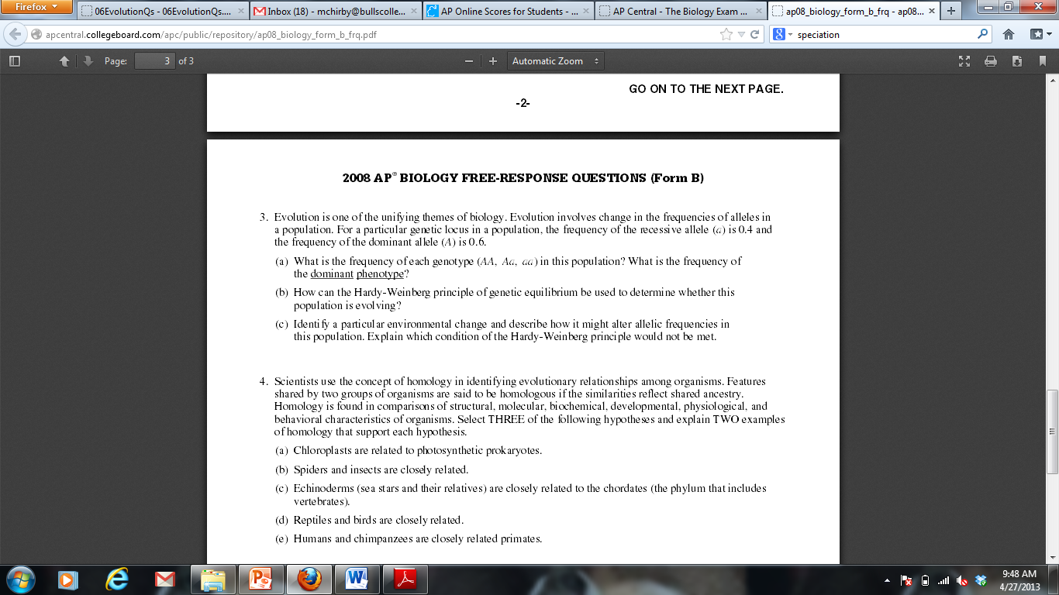

**CONCEPT 8 – ECOLOGY**

1. Populations
2. group of individuals of same species living in same area (size, density, distribution/dispersion)
3. habitat (type of area organism lives) vs. niche (role in ecosystem)
4. competition for resources
5. age structure (rapid growth vs. declining vs. stable populations)
6. population growth
7. density dependent limiting factors (competition for resources, parasites & diseases, waste products, stress, predation)
8. density independent limiting factors (climate = temperature & rainfall, natural disaster)
9. exponential growth (J-shaped, unlimited) vs. logistic growth curve (S-shaped, limited)
10. carrying capacity = maximum population supported by habitat
11. populations can cycle
12. Population ability to respond to changes in the environment is affected by genetic diversity. Species and populations with little genetic diversity are at risk for extinction.
13. Communities
14. measured and described in terms of species composition and species diversity
15. symbiosis = species interaction
16. mutualism +/+ (acacia tree & ants; lichens, N-fixing bacteria & legume plants)
17. commensalism +/0 (egrets & cattle)
18. parasitism +/– (tapeworm, cowbird)
19. predation +/– (carnivores & herbivores)
20. competition
21. Ecosystems
22. Free Energy
23. Reproduction and rearing of offspring require free energy beyond that used for maintenance and growth. Different organisms use various reproductive strategies in response to energy availability.
24. There is a relationship between metabolic rate per unit body mass and the size of multicellular organisms — generally, the smaller the organism, the higher the metabolic rate.
25. Excess acquired free energy versus required free energy expenditure results in energy storage or growth.
26. Insufficient acquired free energy versus required free energy expenditure results in loss of mass and, ultimately, the death of an organism.
27. Energy flow/production = energy flows through; 90% lost at each level & 10% transferred to next level
28. trophic levels = primary producers, primary consumers, secondary consumers, tertiary consumers, detritivores & decomposer
29. ecological pyramids (pyramids of energy, biomass, numbers)
30. food chains & food webs
31. Biotic and Abiotic factors can both cause disruption and collapse of ecosystems

***Vocabulary***

Apex predator

Biomagnification

Biomass

Carrying capacity

Carnivore

Commensalism

Competition

Consumer

Density-dependent

Density-independent

Decomposer

Detrivore

Energy pyramid

Exponential growth

Food chain

Food web

Herbivore

Heterotroph

Logistic growth

Mutualism

Trophic level

Parasitism

Population

Predation

Primary productivity

Producer

***Thinking Questions***

1. Invasive species are species that are introduced into an environment but are not naturally found in that environment. One example of an invasive species is the American gray squirrel, introduced into Britain at the end of the 18th century. Until 1876 the only native squirrel in Britain was the European red squirrel, which was found in deciduous and coniferous forests. By 1940 the gray squirrel had displaced the red squirrel across most of the British Isles, and by 1984 the red squirrel was only found in isolated coniferous woodland areas. After its initial introduction, the gray squirrel population increased rapidly; however, in recent years population sizes within specific environments have become stable.
2. Explain why the newly-introduced gray squirrel initially showed rapid population growth and why the native red squirrel showed a population decline.
3. Why has the population size of the gray squirrel become stable in recent years?
4. The first age structure graph below for country X shows the percent of the population in each age group for the year 2000. The remaining three graphs are projections of how the age structure of country X will change. From these age structure diagrams construct a graph of population size vs. time for 2000-2080 and justify your prediction.

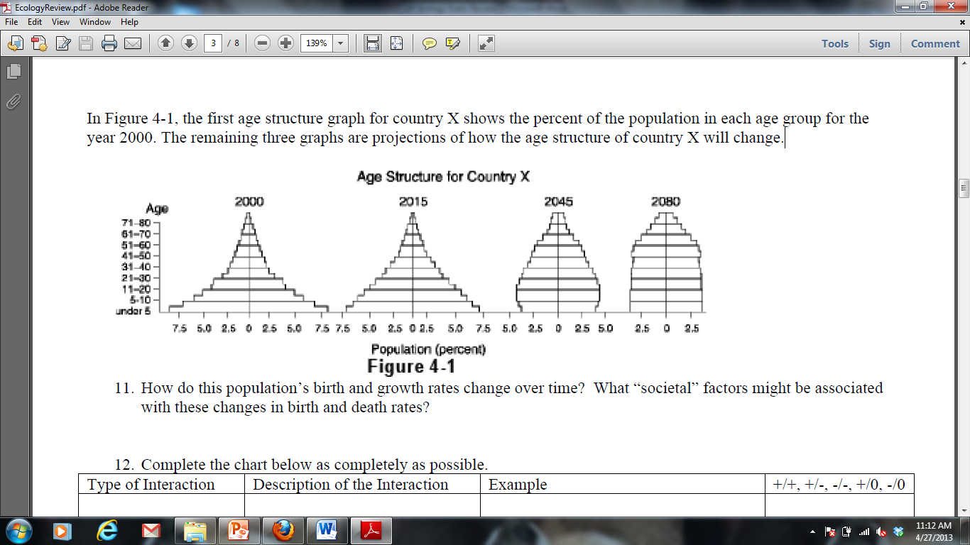

1. The graphs below display the growth rate for two species of bacteria when grown separately and together.

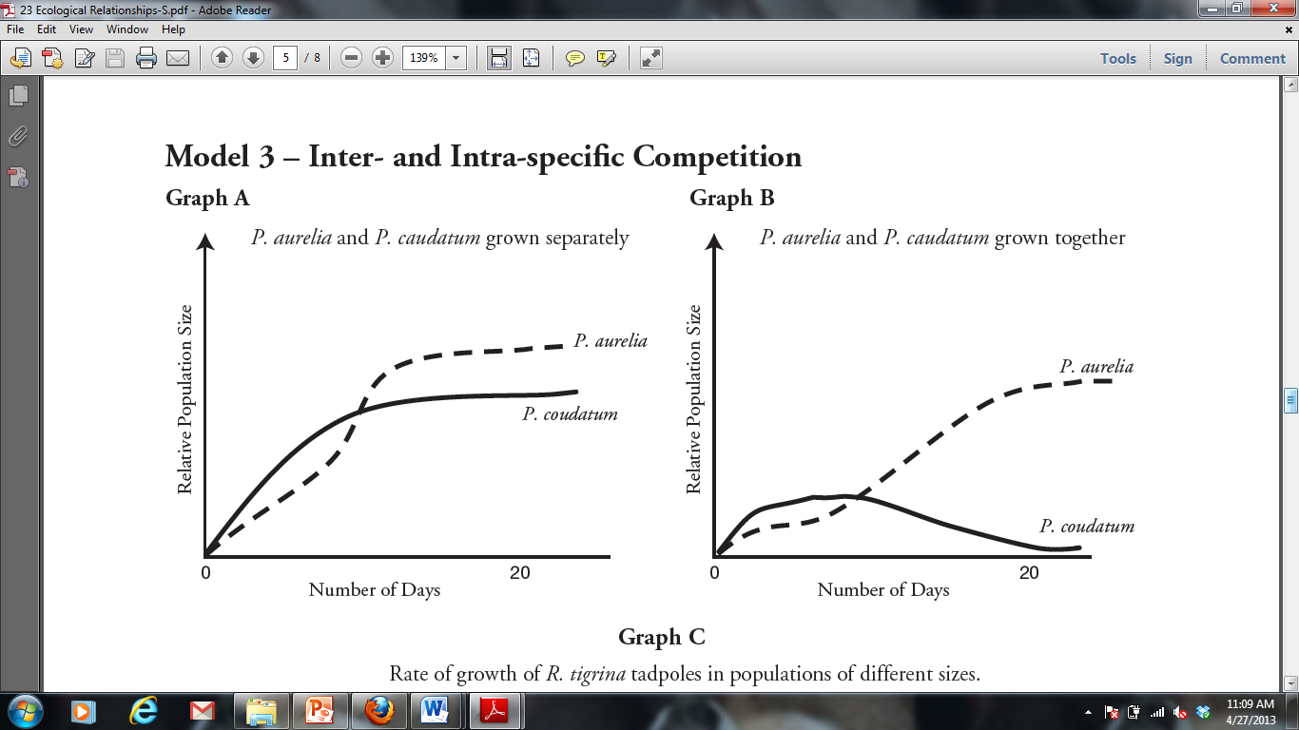

1. The population growth of which bacteria is more affected by growing conditions? Explain how you know.
2. Using the information provided in the graphs, make a prediction as to why the bacteria identified in part a is more affected by growing conditions than the other bacteria.
3. Interdependence in nature is illustrated by the transfer of energy through trophic levels. The diagram below depicts the transfer of energy in a food web of an Arctic lake located in Alaska.

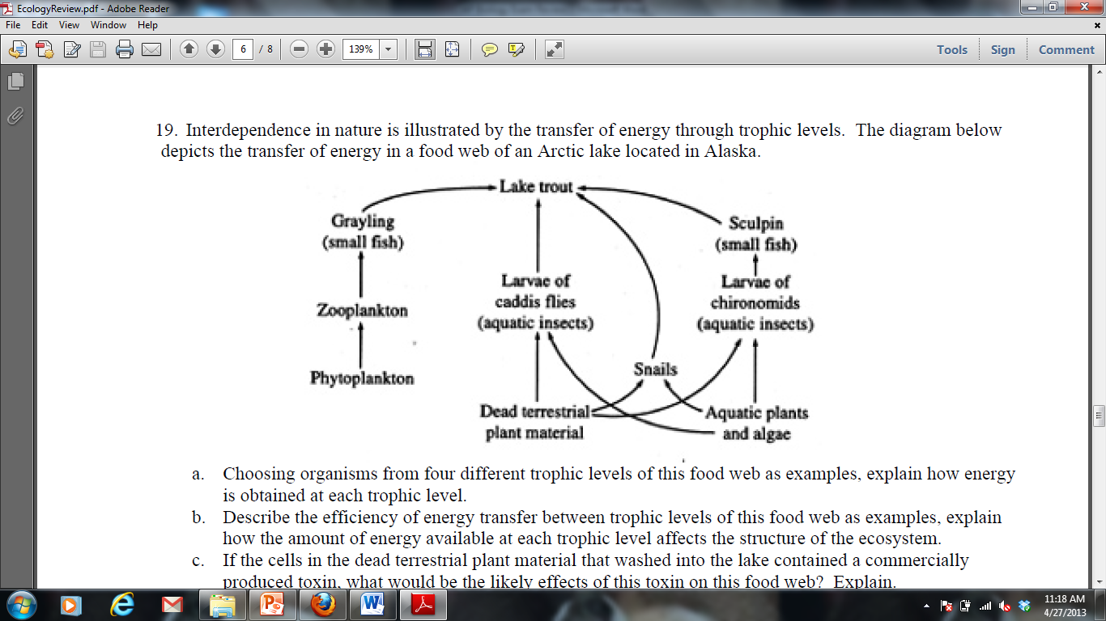

1. Identify an organism from each of the 5 trophic levels (producer, primary consumer, secondary consumer, teritiary consumer and decomposer) and explain how energy is obtained at each level.
2. Describe the efficiency of energy transfer between trophic levels of this food web.
3. Explain how the amount of energy available at each trophic level affects the size of each population.
4. If the cells in the dead terrestrial plant material that washed into the lake contained a commercially produced toxin, what would be the likely effects of this toxin on this food web? Explain.
5. If all of the Sculpin in this ecosystem were removed, predict how it would impact the following and explain each prediction:

* The population of lake trout
* The population of snails
* The population of algae
* The amount of oxygen produced in the ecosystem
* The amount of light energy absorbed by the ecosystem

**Ecology Long Free Response (10 points)**

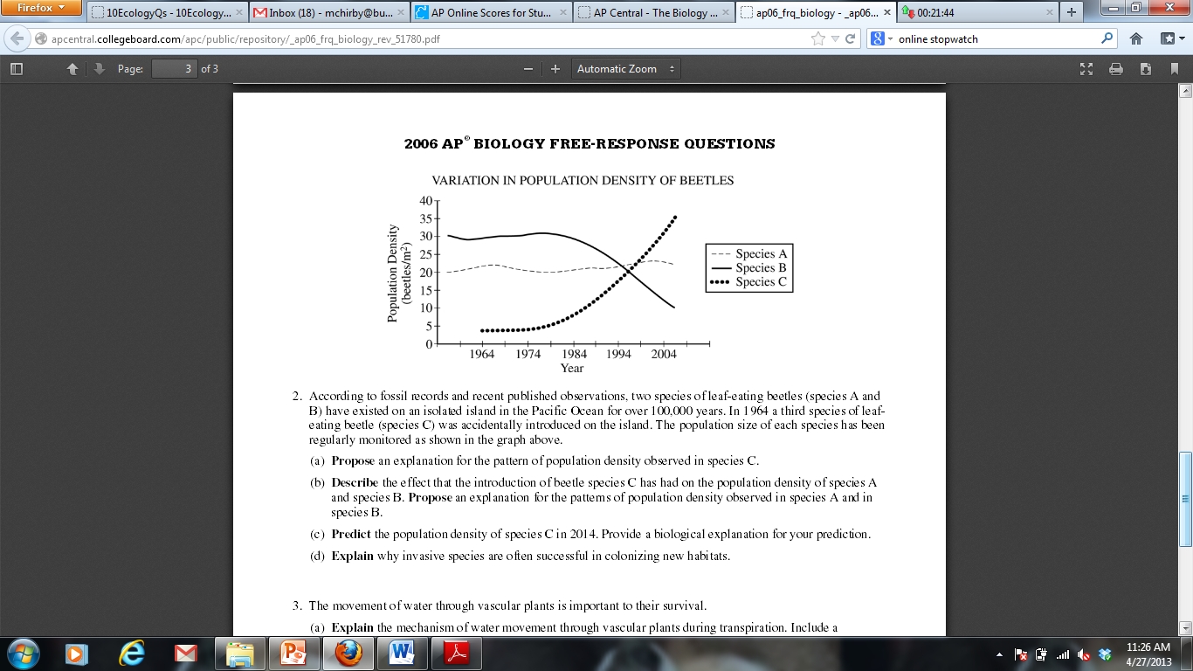

**FREE RESPONSE GRADING RUBRICS**

*Biochemistry Short Free Response – Page 5*

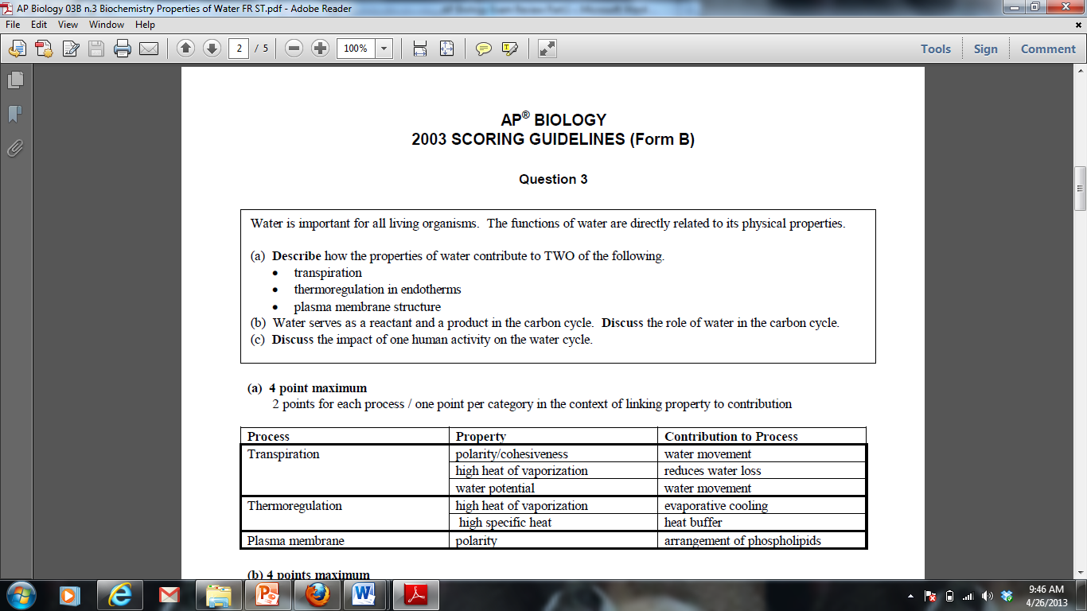

*Cell Long Free Response – Pages 10-12*

**Part A**

1 point correct orientation with dependent variable (concentration) on y (vertical) axis and independent variable (time) on x (horizontal) axis

1 pointcorrect axes labels with units **and** scaling for 5% line on axes provided

1 pointcorrect plotting of all data points including zero (0,0); line is not necessary but if drawn must not extend beyond last data point; dashing line beyond last data point is okay; arrow at end of line is okay.

**Part B**

1 point correct prediction and legend (or label) for 0%, 1%, and 10% lines (0% line flat, 1% line below 5% line, 10% line above 5% line)

1 point correct explanation for 0% line (e.g., since there is no NaCl in the bag no Na+Cl- can diffuse into the water in the beaker)

1 point correct explanation for 1% line — must include a discussion of rate; connects concentration of NaCl with diffusion rate

1 point correct explanation for 10% line — must include a discussion of rate; connects concentration of NaCl with diffusion rate

**Part C**

1 point statement that water will leave the plant and description of effect this has on plant cell (e.g., loss of turgor, plasmolysis, decrease in cell volume, decrease in central vacuole volume)

1 point concept of osmosis (e.g., movement of water across a selectively permeable membrane (cell or cell membrane) from solution with lower solute concentration (hypotonic) to solution with higher solute concentration (hypertonic)

1 point explanation that water moves from solution with higher (more positive/less negative) water potential (ψ) to solution with lower (more negative) water potential (ψ)

1 point explanation of how water loss can cause decreased crop production (e.g., stomates close, transpiration stops, photosynthesis stops, decreased metabolism)

*Energy and Metabolism Short Free Response – Page 19*

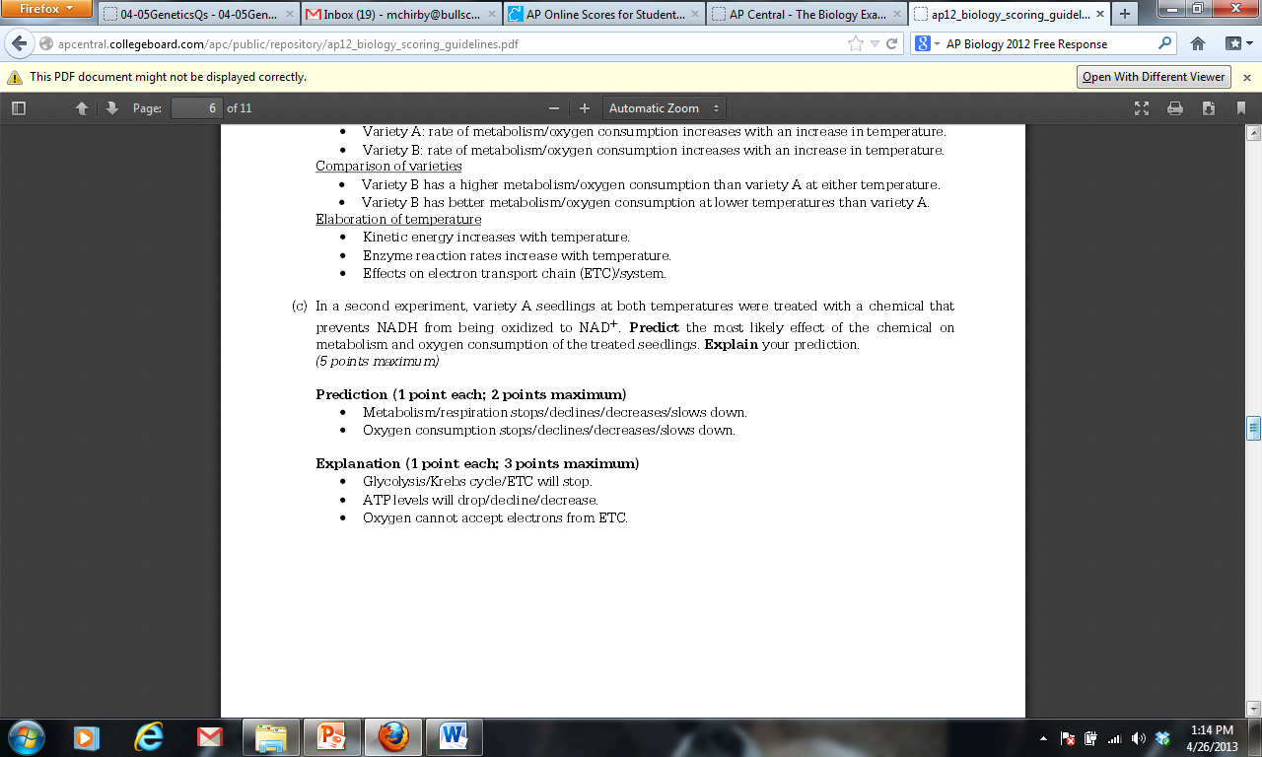

*Cell Cycle and Heredity Short Free Response – Page 25*

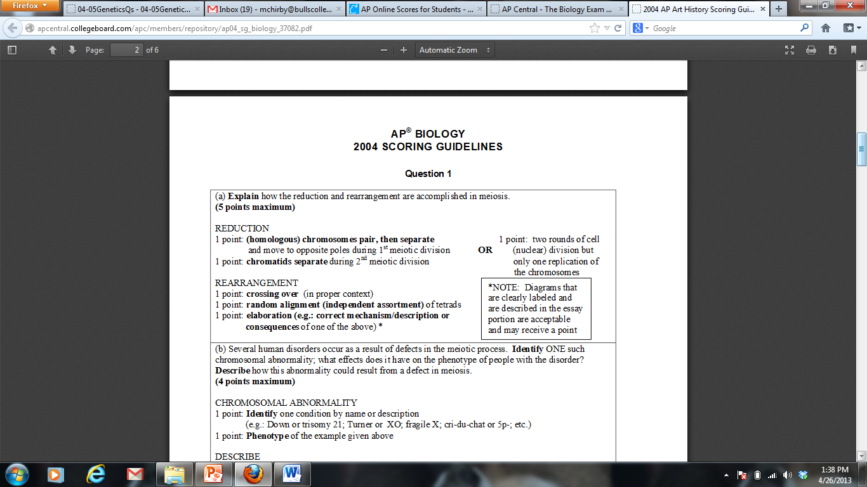

*Molecular Genetics Short Free Response – Page 30*

|  |  |
| --- | --- |
| **SIMILARITIES**  2 POINTS MAXIMUM  1 point for similarity, 1 point for elaboration (in parentheses) | * Synthesize DNA in 5’ to 3’ direction (DNA polymerase III can only work in one direction) * Use RNA primers to initiate replication (primase, DNA polymerase III must have a started sequence to be functional) * Both have RNA primers replaced with DNA (DNA polymerase I) |
| **DIFFERENCES**  2 POINTS MAXIMUM  2 points for difference including description of both strands | * One strand is synthesized as one, continuous strand (leading strand), while the other is synthesized in fragments (lagging strand). * Lagging strand must use ligase to connect segments of DNA, while leading strand does not require use of this enzyme. |

*Evolution Long Free Response – Pages 42-44*

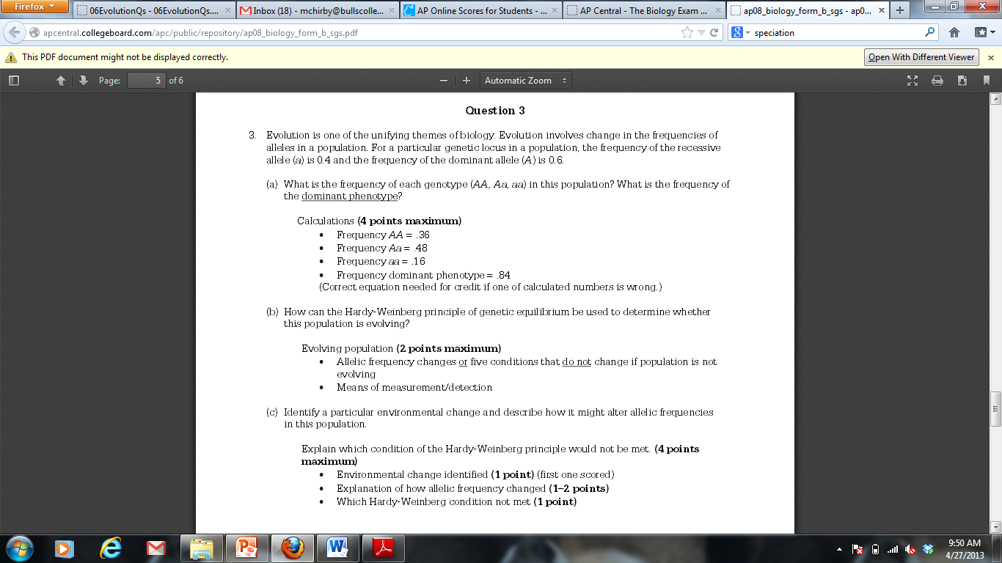

*Ecology Long Free Response – Pages 49-51*

